Home Learning
English
Today, you are going to have a go at writing a descriptive piece of writing. Please look at the questions below to help you.

A Day on my Island
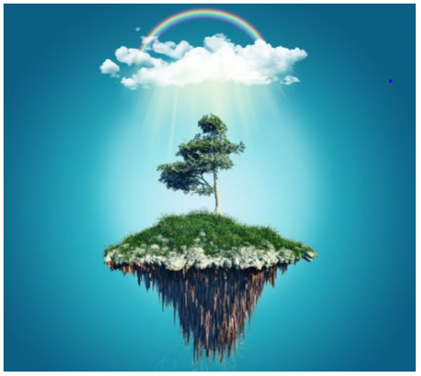

Design your own floating island (just like the picture). Consider:
- What size and shape will it be?
- What vegetation is on the surface?
- What will provide you with shelter?
- What is the weather like above you?

Use these questions in your writing, by writing the question and underlining it and then writing a sentence to answer that question.

Remember: This is your island, think about what you need to help you on this island.

