Home Learning
English
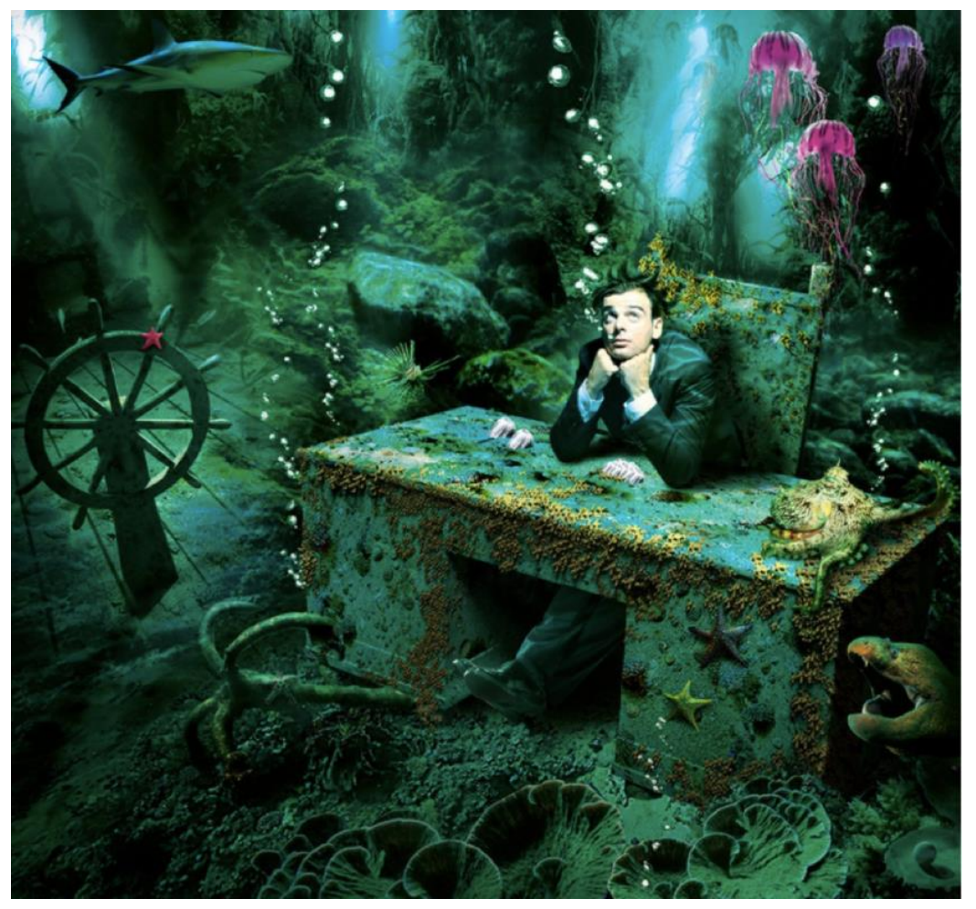
Today, you are going to have a go at looking at the photos below and answer the questions. There is no wrong answer. All you need to do is give your answer and evidence from the picture.

1. Why do you think the man went underwater in the first place?
2. Who do you think the man is?
3. What do you think he is looking at?
4. What do the sea creatures think about him being there?
5. Why is he wearing a suit?

