English
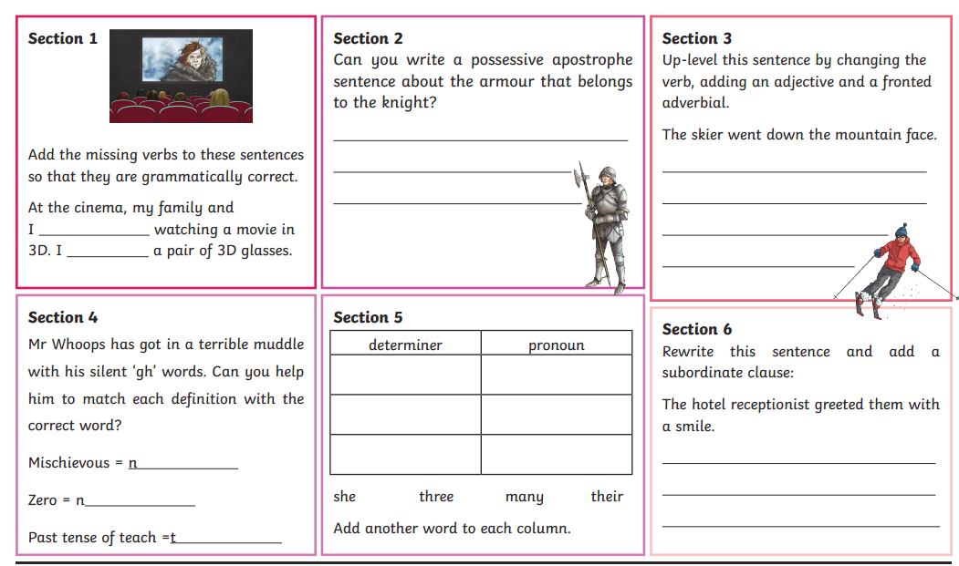
Challenge
Look outside your window- what do you see?
Write a detailed description of the view outside your window. This could include, for example, trees, fields, animals, houses, parks, traffic or cars. You can describe anything!
It needs:
- Lots of interesting adjectives and verbs
- Conjunctions
- Punctuation

