English
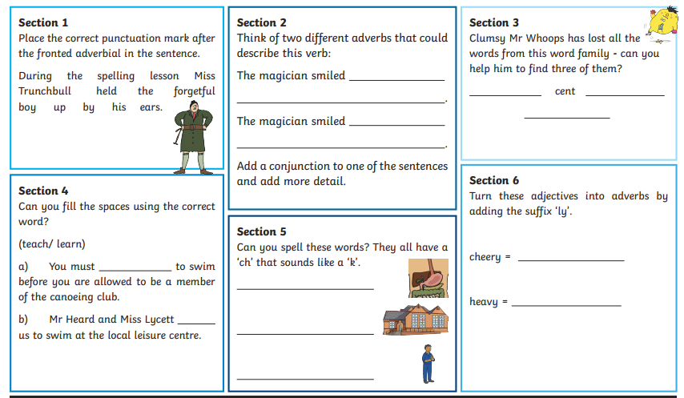
Extension
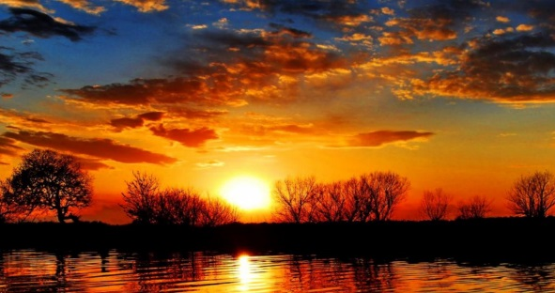
Write a detailed paragraph to describe this image of a sunset.
Use:
- Fronted adverbials
- Nouns and adjectives
- Subordinating conjunctions
- Interesting language

