Home Learning
Maths
Today we are going to look at working out the perimeter of irregular shapes. Please look at each measurement of each shape and add them together to work out the perimeter of each shape.
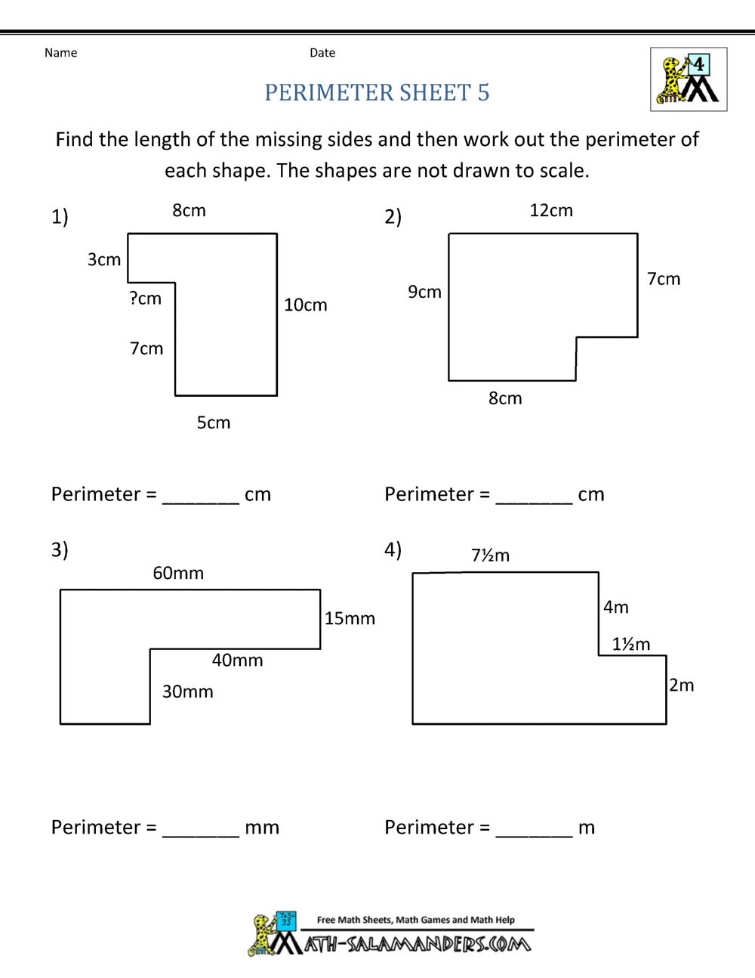
2cm
4cm
6m
45mm
8m
1m
7m
3cm

