Home Learning
Maths
Today we are going to learn about perimeter. Please look at the mastery questions below and answer them on paper.
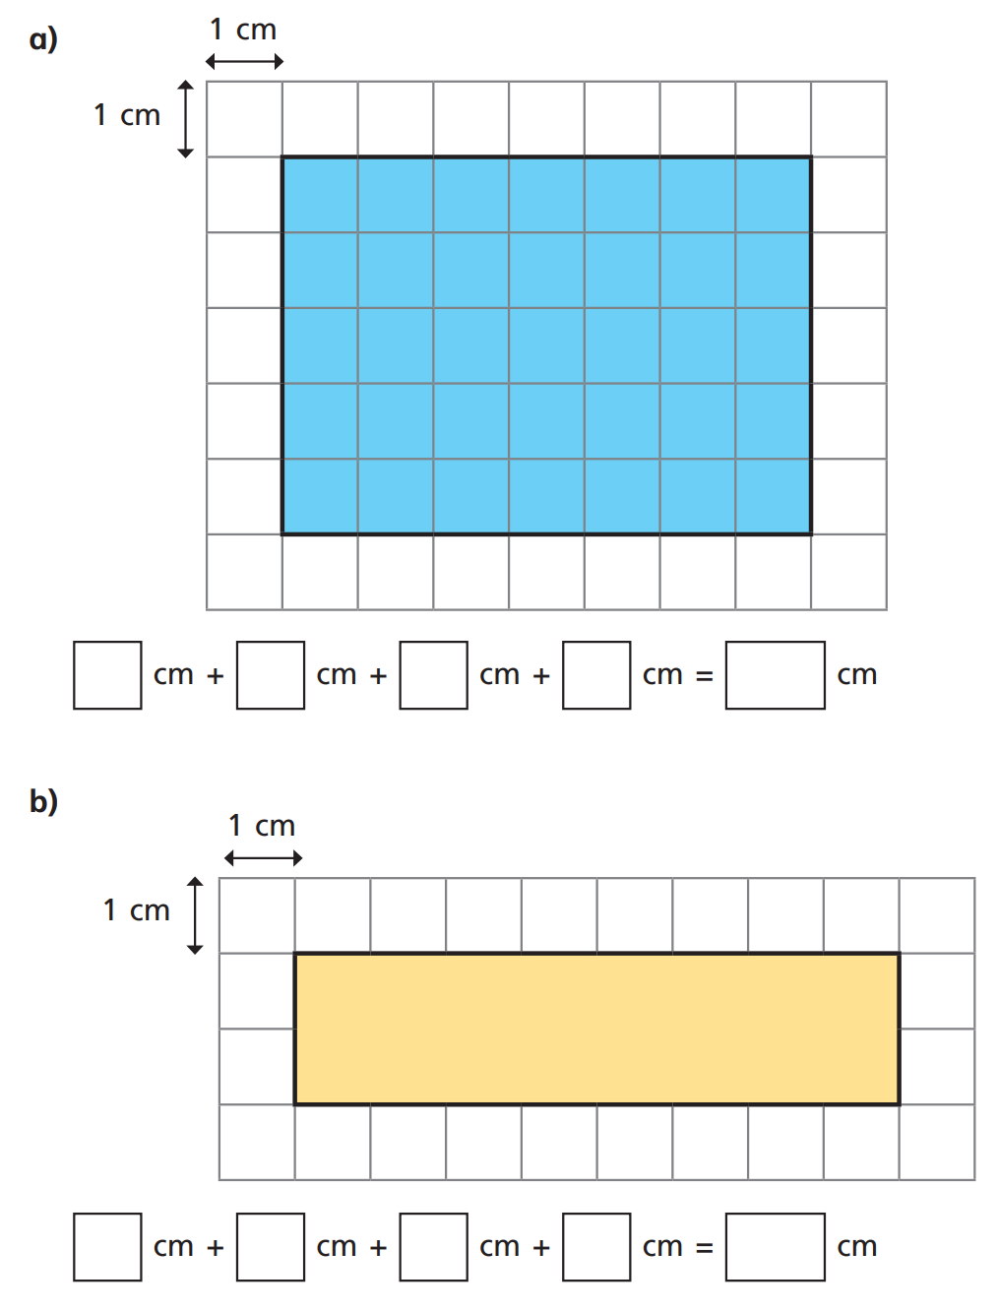
Question 1:

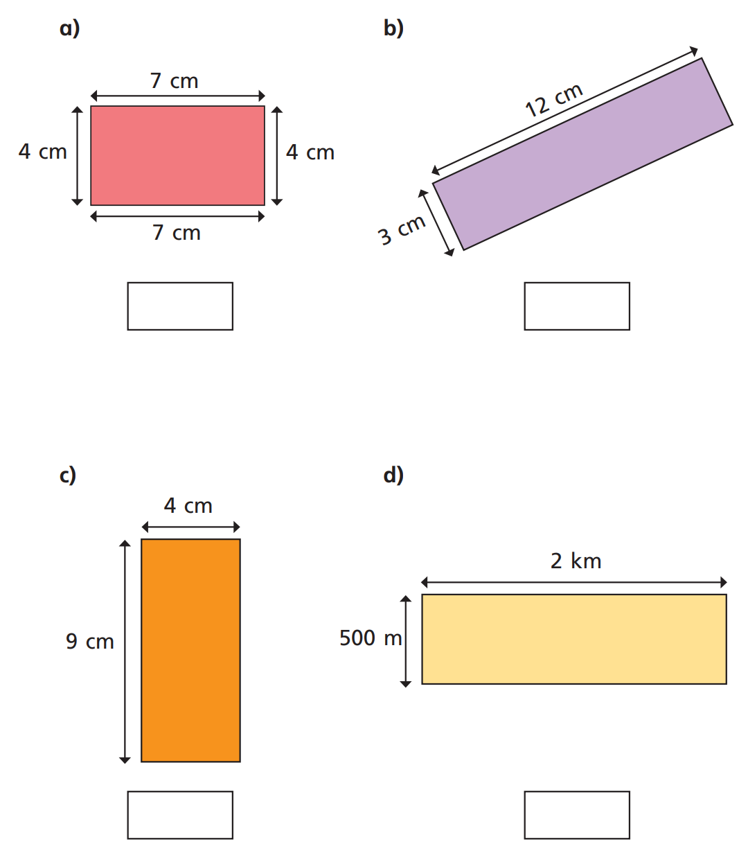
Question 2:

