Home Learning
Maths
Yesterday, we looked at doing a table. Today, we are going to create a pictogram. Please follow the link below. The activities will be on the page underneath.
Link: https://www.bbc.co.uk/bitesize/articles/z493hcw
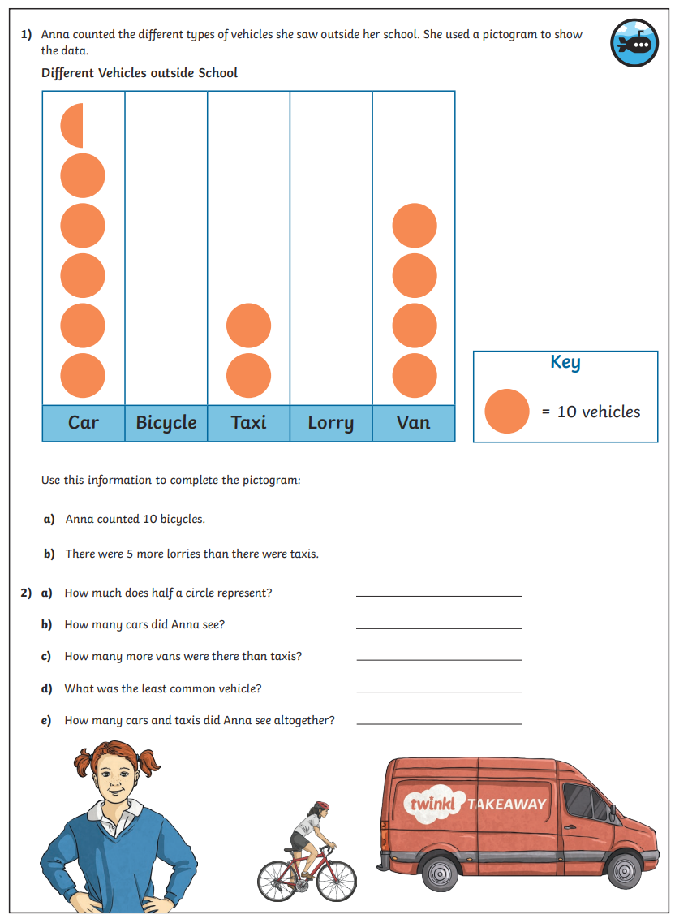
Activity 1:

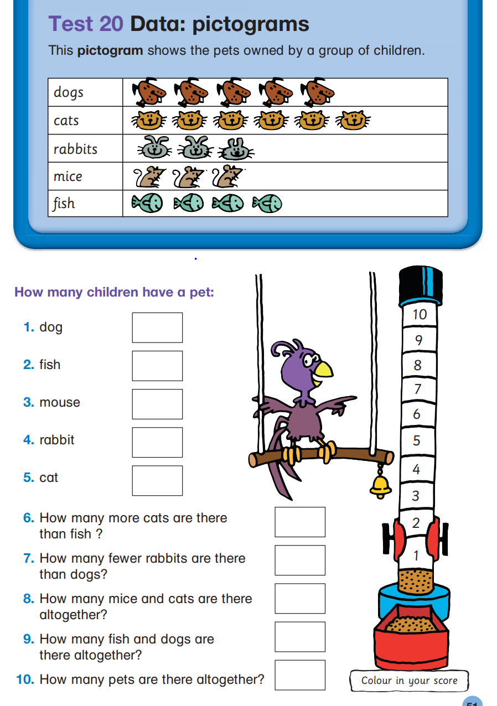
Activity 2:

