Maths- Multiplication and Division
Choose Set A, B or C and complete a mixture of multiplication and division number sentences. Set C is the most challenging.
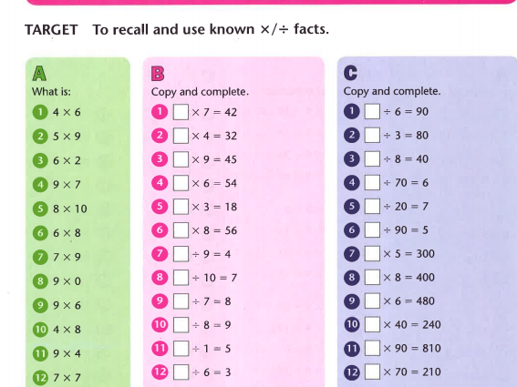

Challenge

