Maths- Ordering Numbers
Choose Set A, B or C to order and compare numbers beyond 1000.

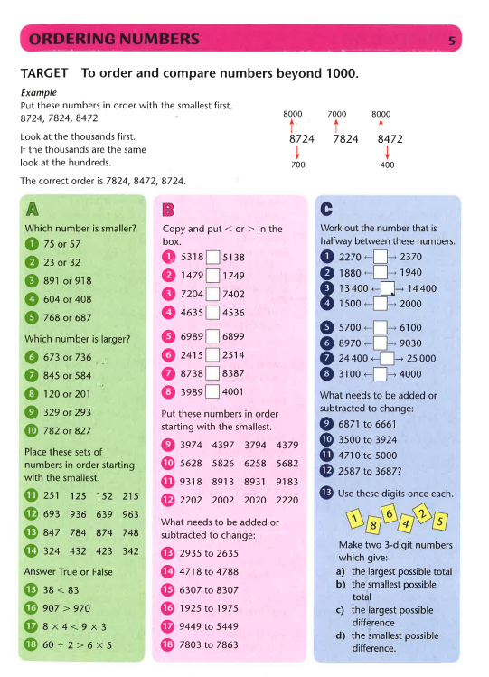

Challenge

