Choose Set A or B and work out the addition maths stories to answer each question.
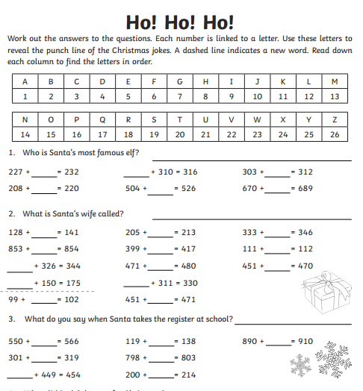
Set B is more challenging.
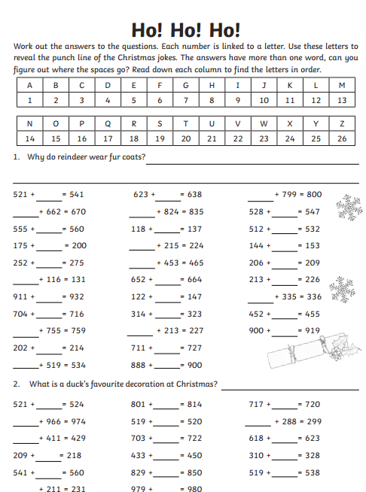
Set A Set B

