Choose Set A or B and complete the Maths stories by colouring each square in the correct colour.
Set B is more challenging.
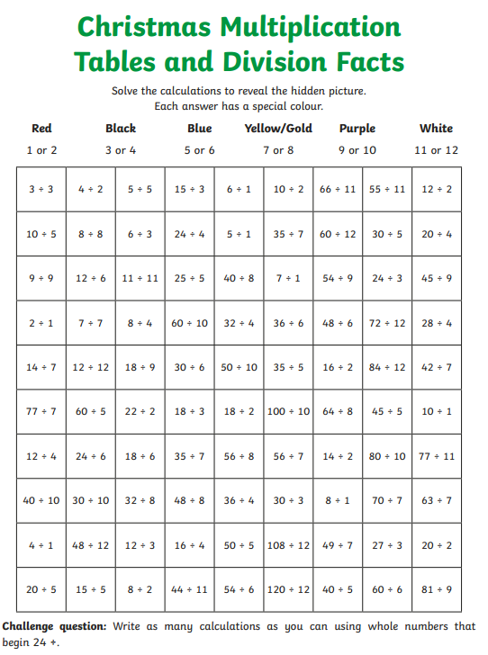
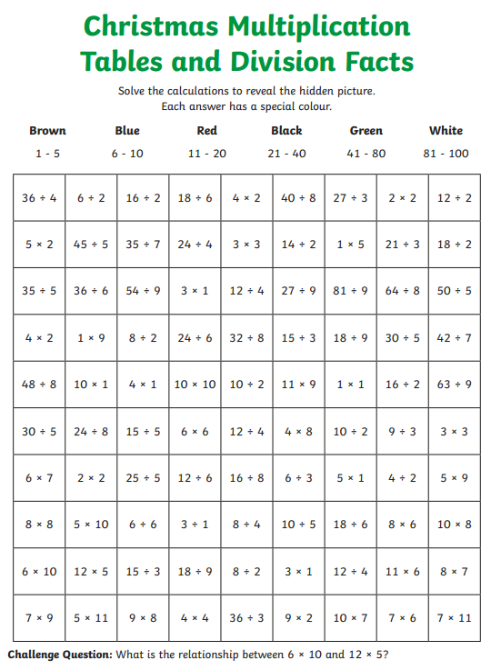
Set A Set B

