Maths- Addition and Subtraction
Choose Set A, B or C and complete a mixture of addition and subtraction number sentences. Set C is the most challenging.
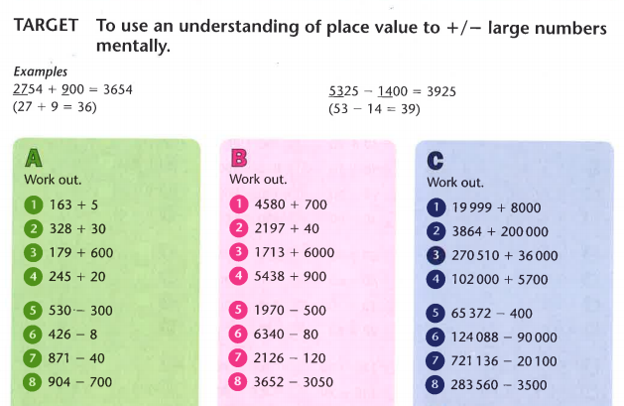

Challenge

