English 14.12 – Using prepositions

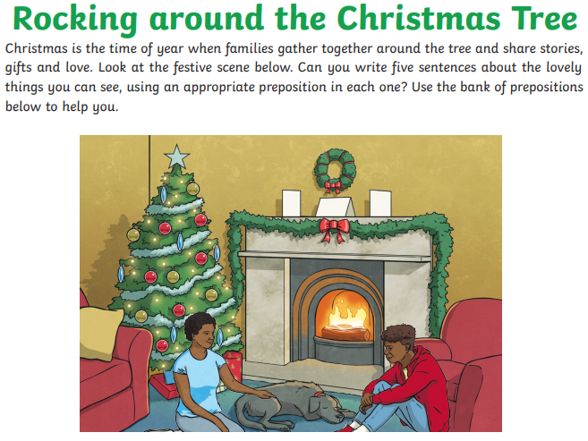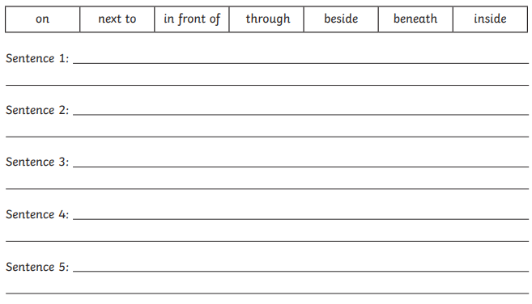
Challenge – How many different types of punctuation can you use?

