Home Learning
Writing
Today, you are going to have a go at writing an ‘Information Text.’
Lion | Elephant | Giraffe | Meerkat
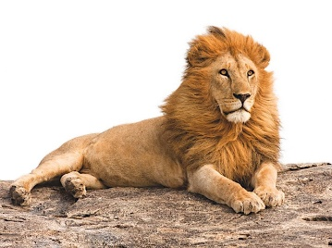 | 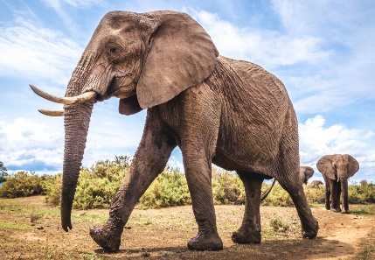 | 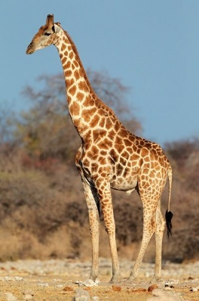 | 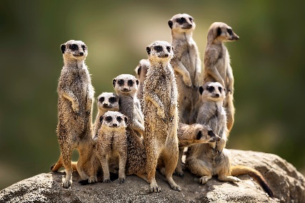
Rhino | Warthog | Cheetah | Zebra
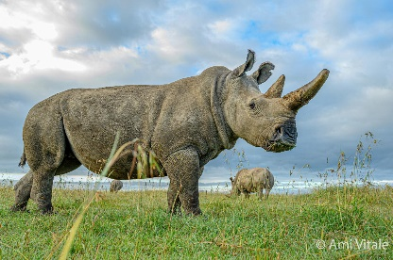 | 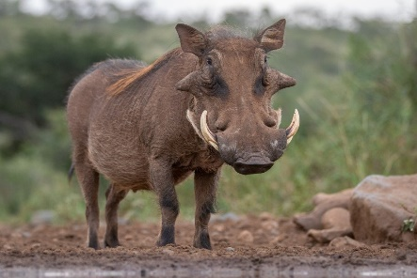 | 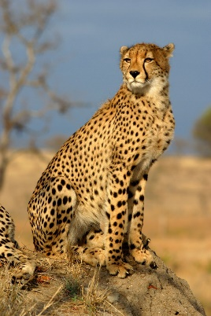 | 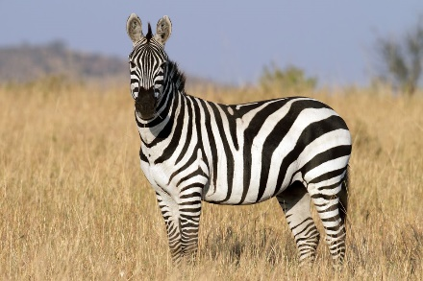
1. Select an animal from the photos below to do some research on. These animals are all African animals.

2. Use the headings below to help you with your research.
- Please go through this link to do your research to keep safe on the internet: https://www.kiddle.co/
Headings:
- Where do they live in Africa?
- How do they survive?
- What do they eat?
- Challenge: Can you describe what they look like?

3. The purpose of this text is to write a fact file on this animal for a Zoo.

