Home Learning
English
Today, we are going to write a diary. Please follow the link below and watch the video. Make a note of any interesting words in the story and magpie them for your own writing.
Video Link: https://www.bbc.co.uk/bitesize/articles/zmmj7nb

Features of a Diary Entry:
- Starts with ‘Dear Diary.’
- Describe the places where the events happened.
- Write in the past tense.
- Use pronouns like, I, my and me to show that the events happened to you.
- Talk about how you were feeling.
- Talk about what you were thinking.
- Use interesting vocabulary.

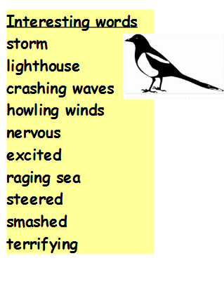
Activity:
Using your plan (from yesterday), you are going to write a diary entry as ‘Grace Darling’ on the night of the rescue. Start a new paragraph for every subheading in your plan.
I have written an example with describing words missing. If you need some help you can use this to support your writing and fill in the blanks. If you can write your own diary then please do! Don’t forget to use the features of a diary (above) and to use punctuation and the correct spellings. If you want to check spellings, you can use an online dictionary and thesaurus: https://www.dictionary.com/
Dear Diary,
One stormy evening, I looked out of the window. The waves were __________ and the wind was ____________ . I felt ____________ because ________________________________________________________ .

Suddenly, I could see people in trouble. They looked ________________ . I was ________ because the sea was raging and these people were in trouble. I needed to help them.

At the top of my voice I to my dad to get some help! We go into rescue boat and __________ towards to people in trouble. We steered the boat towards them and when we got there …
Until next time.
Grace

