Home Learning
English
Today, we are going to edit our diaries.
Make sure you have used the features of a diary entry.
Features of a Diary Entry:
- Starts with ‘Dear Diary.’
- Describe the places where the events happened.
- Write in the past tense.
- Use pronouns like, I, my and me to show that the events happened to you.
- Talk about how you were feeling.
- Talk about what you were thinking.
- Use interesting vocabulary.

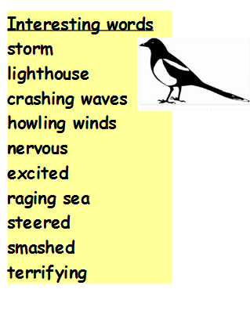
Activity:
Edit your work.
Read through you work to check for the following:
- Capital letters and full stops
- Spellings (High Frequency Word list and www.dictionary.com)
- Have you used interesting vocabulary? Can you magpie from the Interesting words list? You can use a thesaurus to look for interesting words www.thesaurus.com.
- Can you level-up on your punctuation? - ? ! ; “ “ ( )

Resources
