Home Learning
English
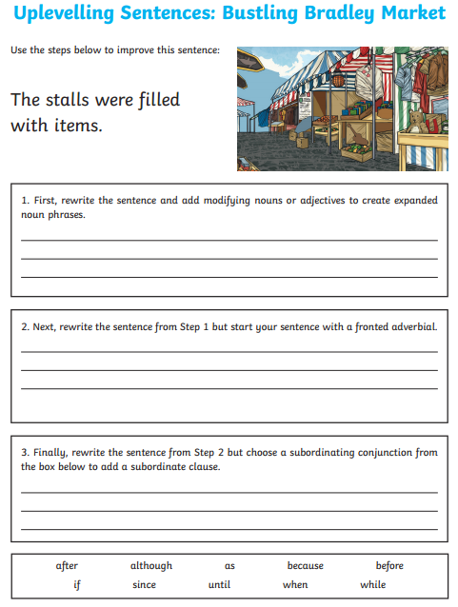
Extension
Write your own sentences to describe the picture. You can magpie some ideas from the resources below.
Include:
- expanded noun phrases
- fronted adverbials
- subordinating conjunctions

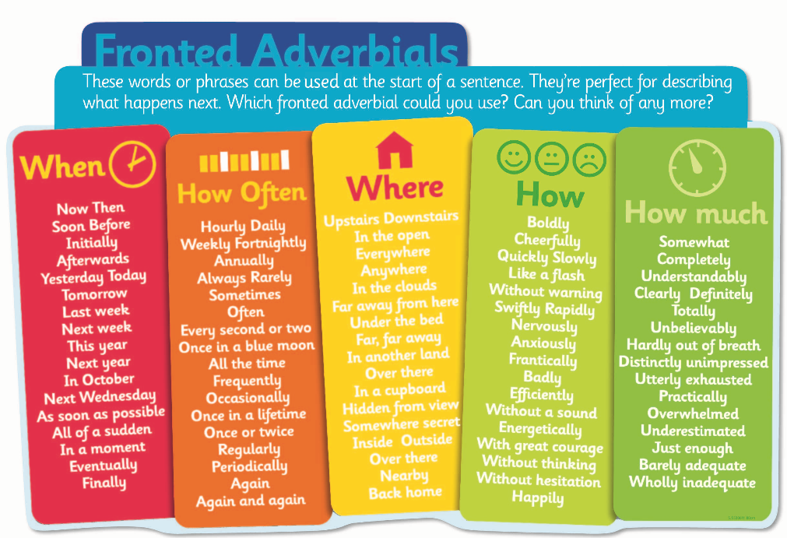
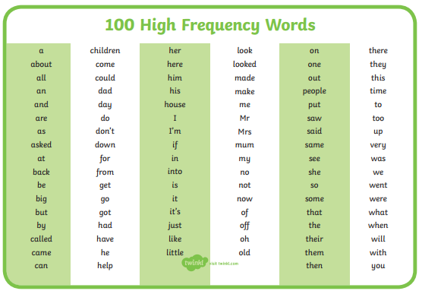
Resources
