Home Learning

Maths

Complete the following sequences

- 3 6 9 _____ 15 _____
- 24 21 _____ 15 _____ 9
- ____ 24 27 30 _____ 36
- 45 _____ _____ 36 33 30
- 12 _____ 18 21 _____ 27
- _____ 48 45 _____ 39 36
- 39 42 _____ 48 _____ 54
- 21 _____ _____ 12 9 6
- _____ _____ 21 24 27 30
- 54 51 _____ _____ 42 39

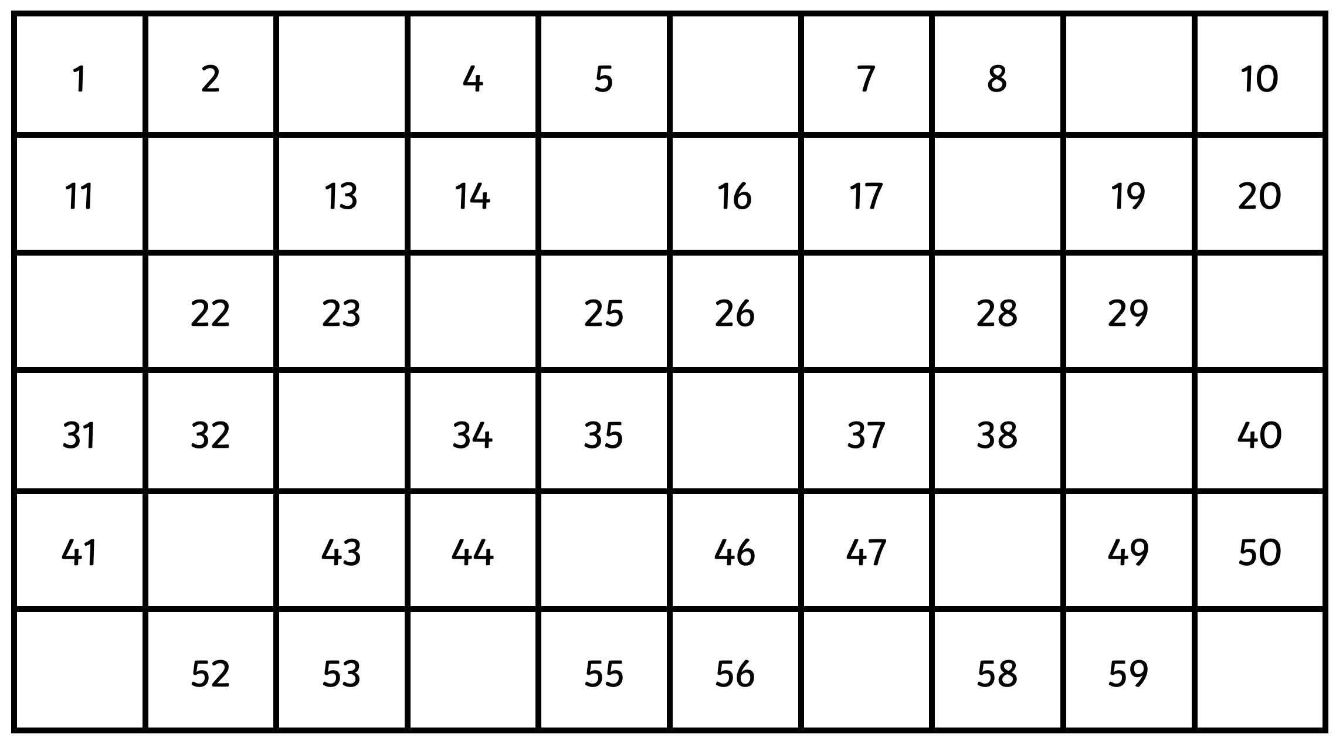
Complete the square below:

Completes the sentences:

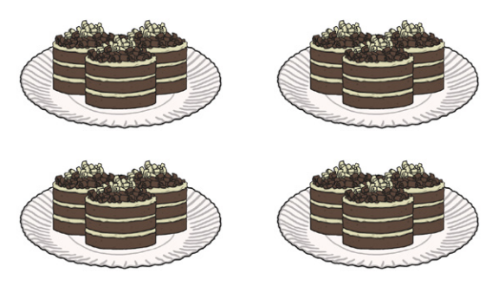

____________ x ______________ = _____________

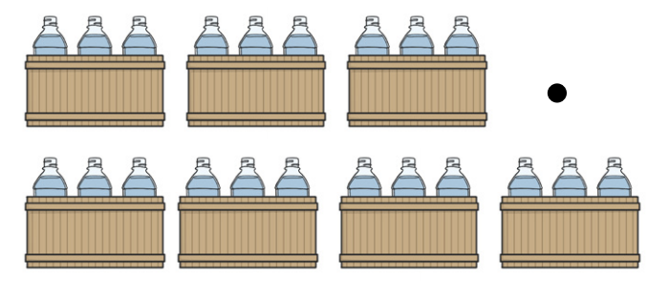

____________ x ______________ = _____________

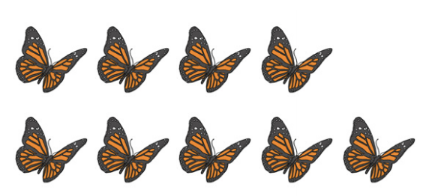

____________ x ______________ = _____________

____________ x ______________ = _____________

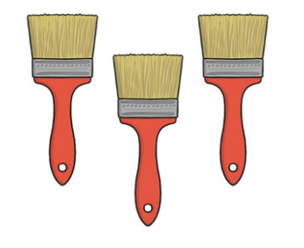

____________ x ______________ = _____________

