Choose Set A or B and work out the addition maths stories to answer each question.
Set B is more challenging.
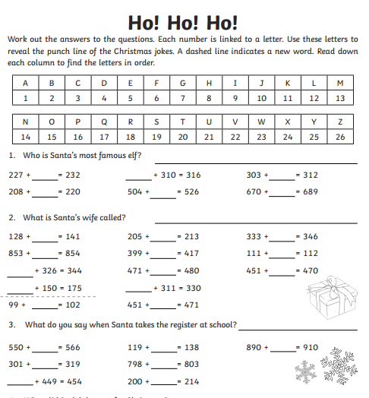
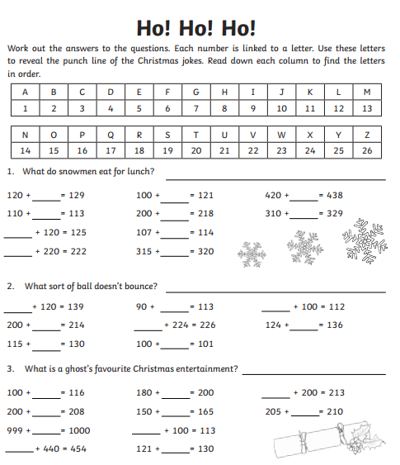
Set A Set B

