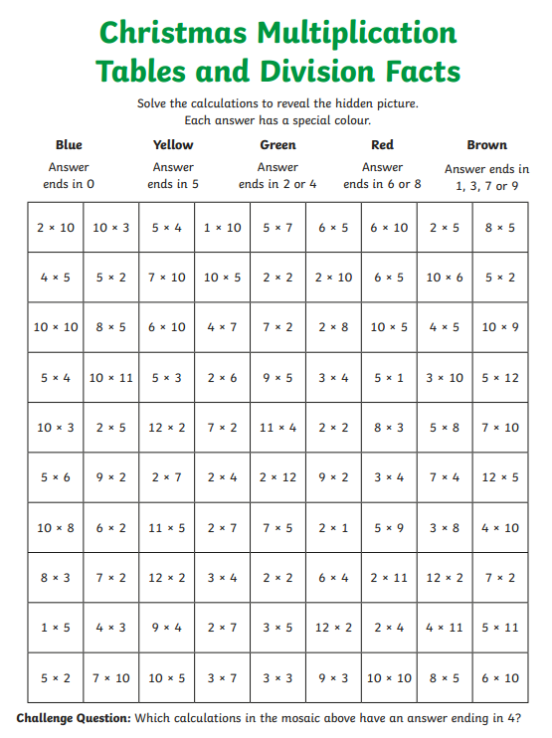
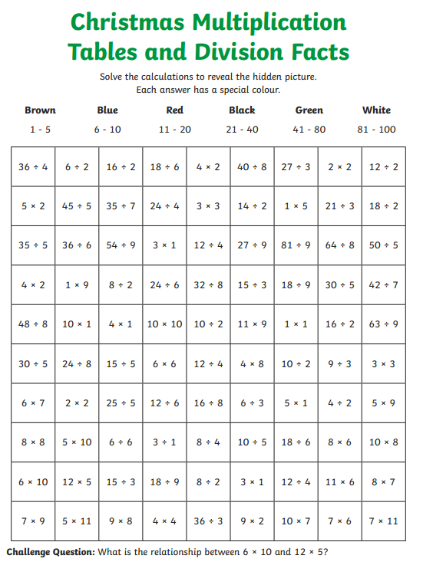
Choose Set A or B and complete the Maths stories by colouring each square in the correct colour.
Set B is more challenging.
Set A Set B

