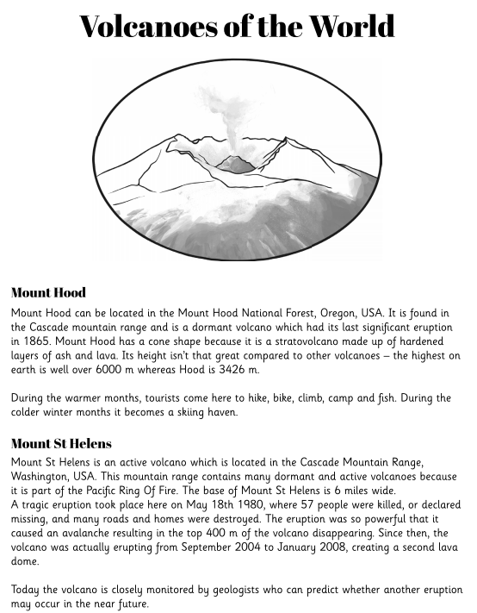

Read the text and complete these sentences.
- Mount Hood is located in the Mount Hood National ______________.
- During the warmer months, tourists come here to __________, _________, __________ and _____________ .
- Mount St Helens is an ___________ ____________ which is located in the Cascade Mountain Range, Washington, USA.

