Reading – All about Fossils
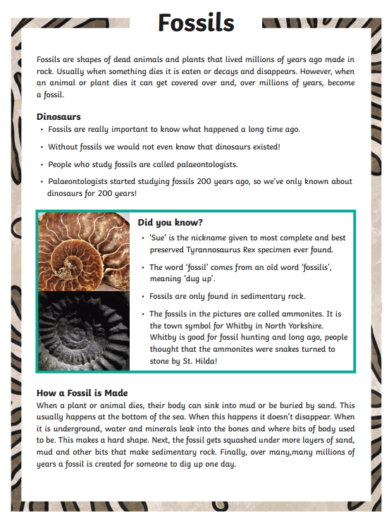
Complete the following sentences
- Fossils are shapes of dead animals and plants that lived millions of years ago________ ______ _________ .
- Without fossils we would not know that ____________ ___________.
- People who study fossils are called _________________.

