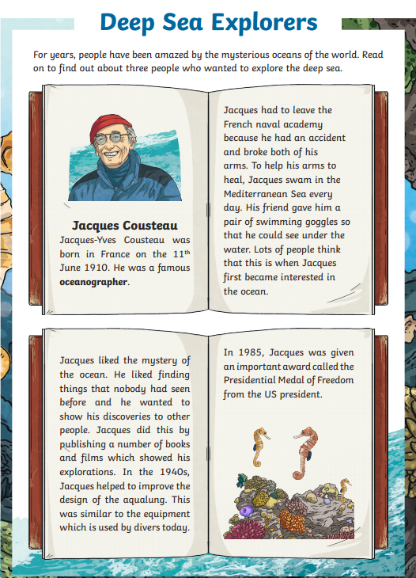

Read the text and complete these sentences.
- Jacques Cousteau was born in France on the ______ _______ _______.
- He was a famous ____________.
- Jacques like the mystery of the __________.
- In 1985, Jacques was given an …

