Science
Today we are learning about fossils.
Watch this video clip and read through the PowerPoint (on the home learning link) to find out about the fossilisation process. https://www.bbc.co.uk/bitesize/topics/z9bbkqt/articles/z2ym2p3

Task: Order the pictures in the correct order and with the correct description to describe the process of fossilisation. 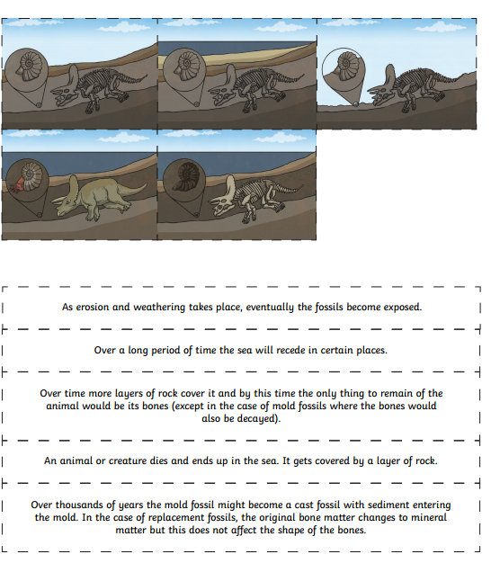
Extension
Can you describe/ explain what a fossil is?

