Maths 14.12

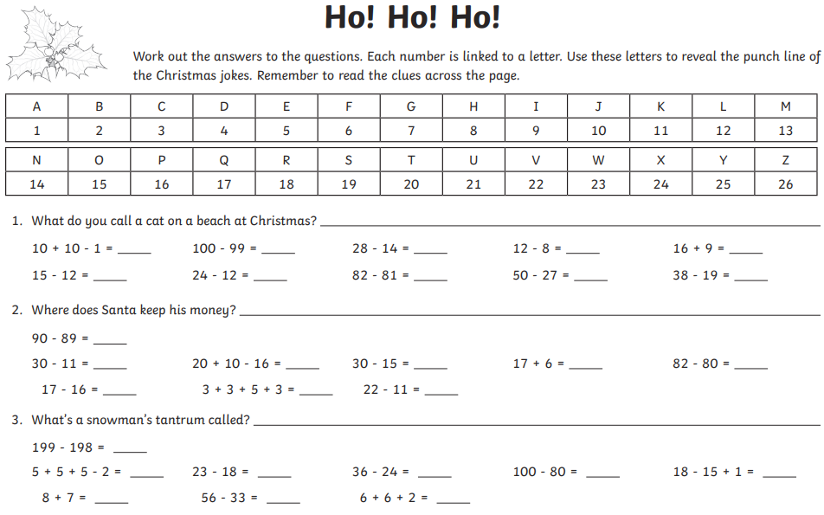

**Answers below**

