Maths 14.12 – Challenge
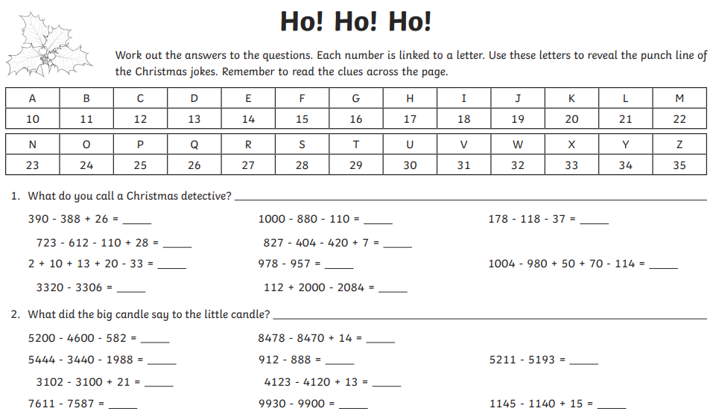
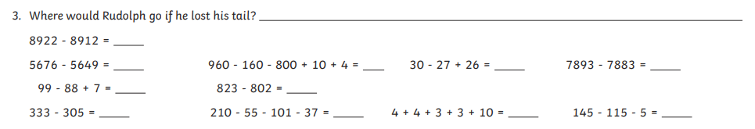

Find the answers below

