Home Learning
English
Today, we are going to plan a letter. Please follow the link below and watch the top video.
Link: https://www.bbc.co.uk/bitesize/articles/z6hvgwx

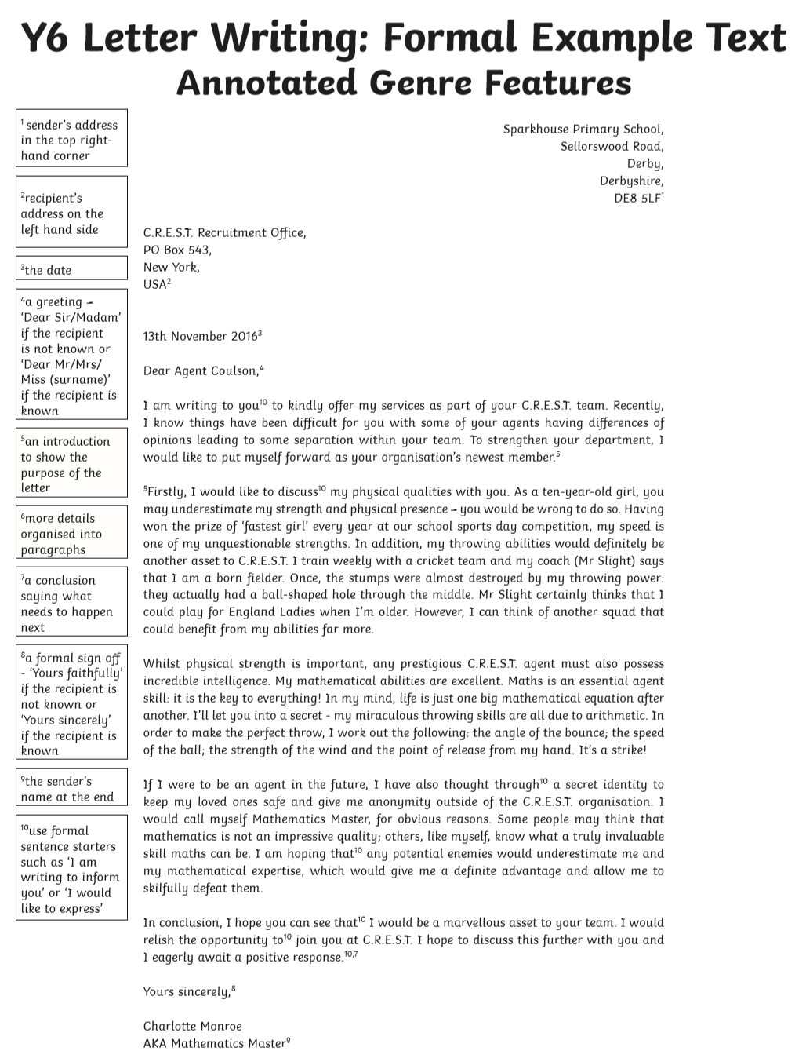
Features of a Letter: The boxes to the side, show you what features to include and each section is numbered to show you where to put them.

Activity:
Please write a plan for a letter. You are going to write a letter to a healthcare professional thanking them for everything they have done during this time. Below is a template for your plan.
Your address:
____________________________________________________________________________________________

How will you end your letter?
_______________________________________________

Paragraph 3:
________________________________________________________________________________________
________________________________________________________________________________________
________________________________________________________________________________________

Paragraph 2:
_______________________________________________________________________________________
_______________________________________________________________________________________
_______________________________________________________________________________________

Paragraph 1:
________________________________________________________________________________________
________________________________________________________________________________________
________________________________________________________________________________________

How will you open your letter?
______________________________________,

Their address:
NHS Healthcare
United Kingdom
Kent
CT3

Date: _________________________________

