Home Learning
English
Today we are going to be writing our letters using our plan to a healthcare professional thanking them for all they have done in this time. Please follow the steps below.
1. Please watch the video again to recap the features of a letter: https://www.bbc.co.uk/bitesize/articles/z6hvgwx
2. Please look below to see how to lay your letter out.
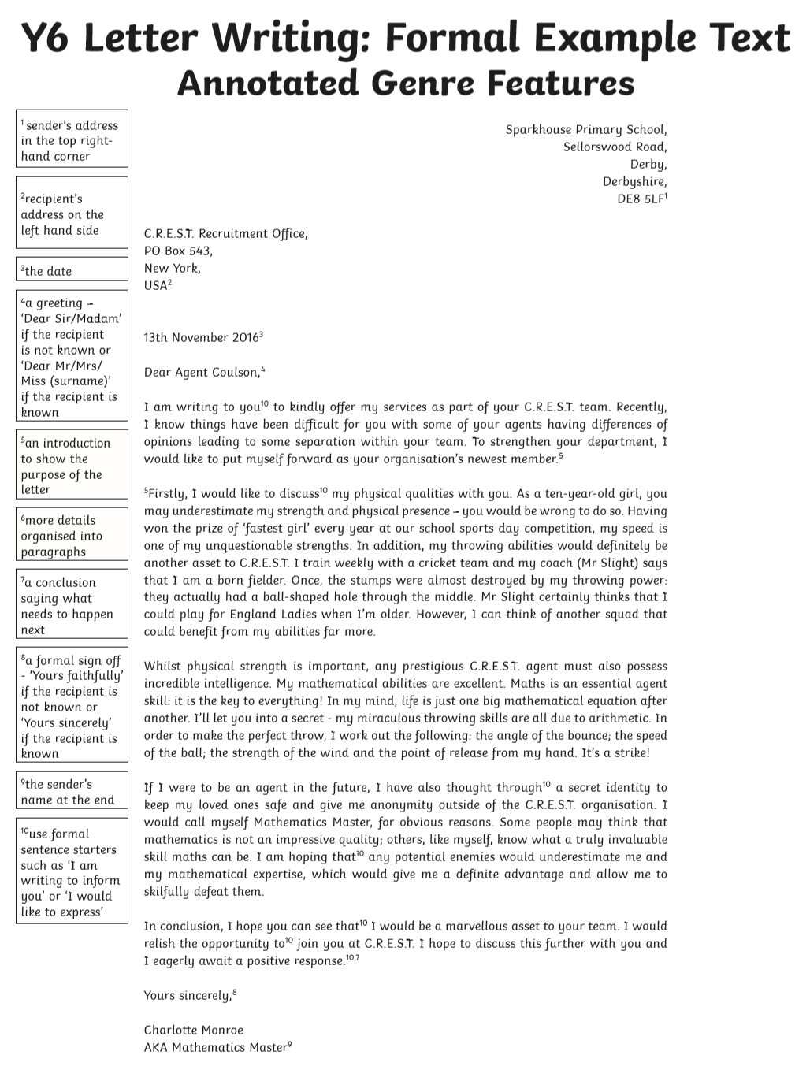
3. Finally, please use your plan to write your letter in full sentences.

