English
Describe the girl and her brother in the picture.
You need to improve the sentence to make it more descriptive.
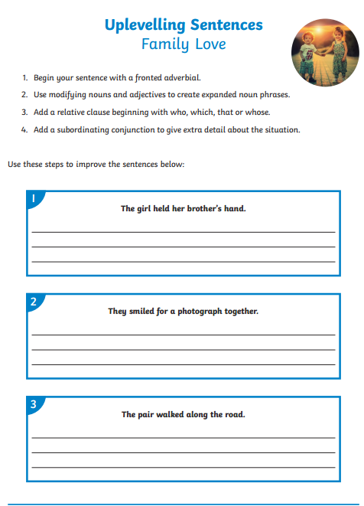
Challenge
Can you write your own sentence to describe the picture and up-level the sentence to improve it?

