**Home Learning**

**Maths**

Today we are looking at multiplying decimals by a whole number. Please watch the two videos below and read the information available to complete the activities underneath.

Video: <https://www.bbc.co.uk/bitesize/articles/zhfj2sg>

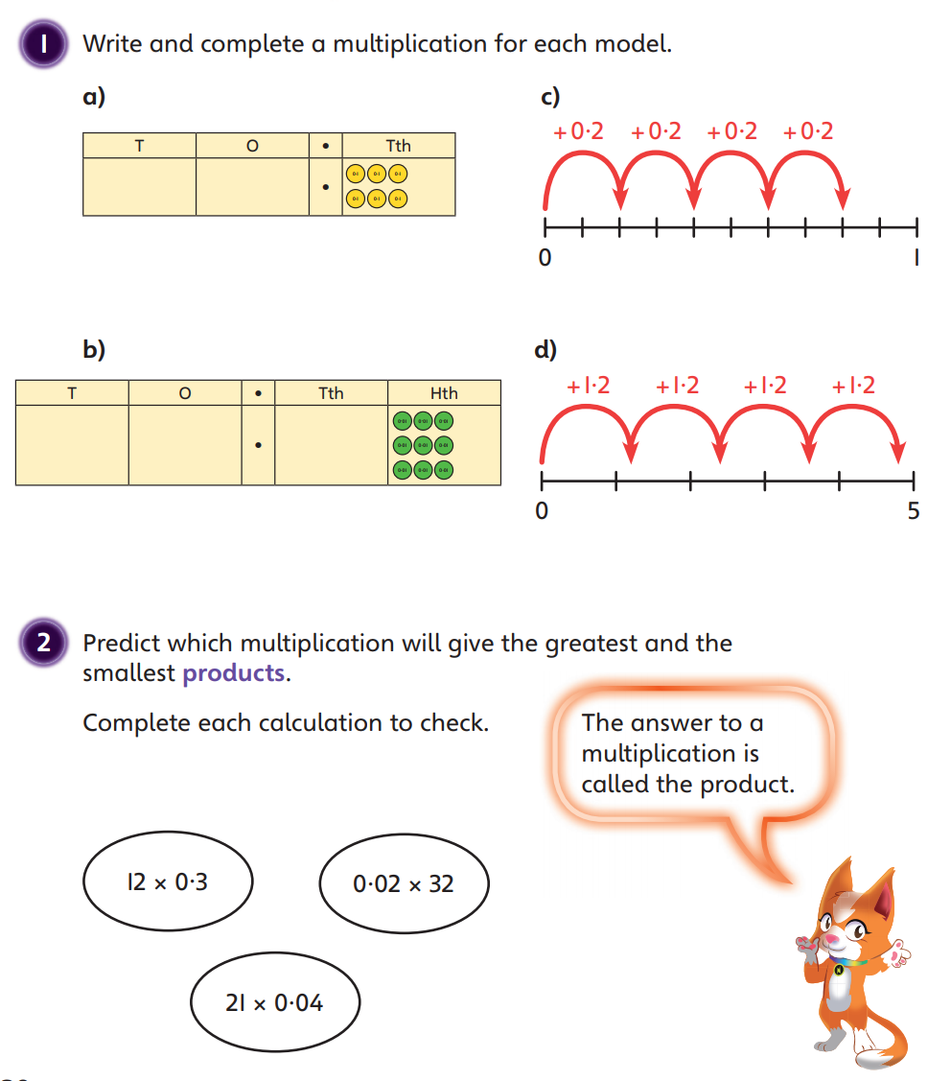

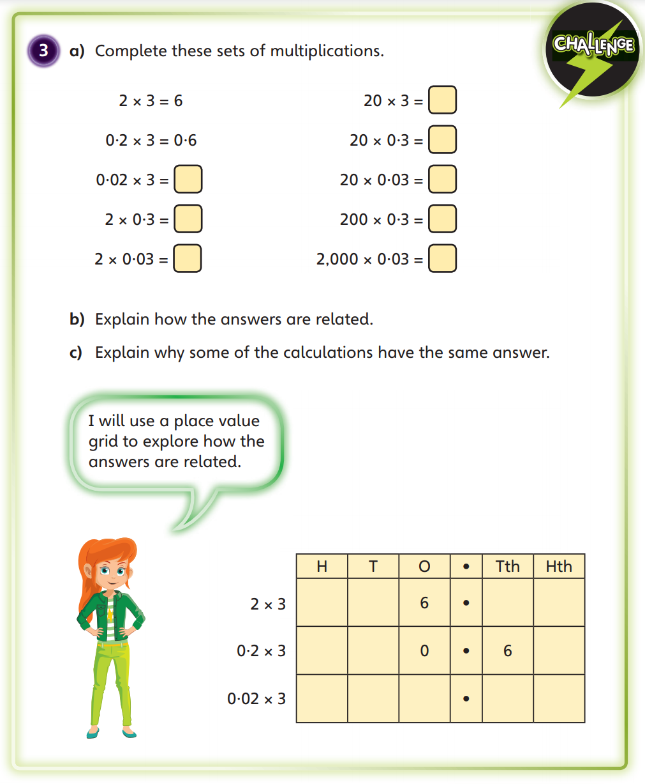

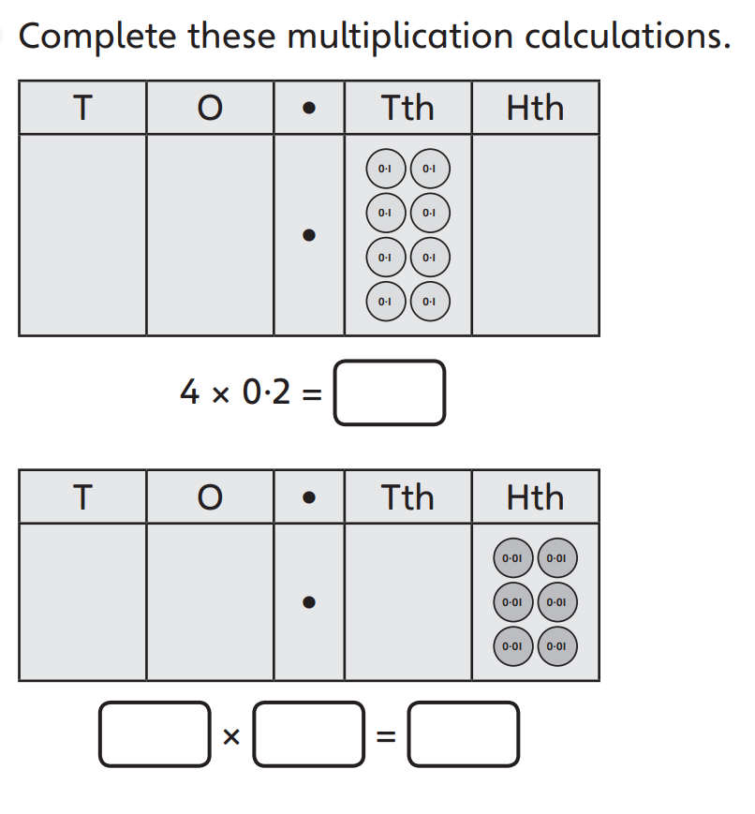Challenge: