Home Learning
Maths
Today, we are going to learn about adding and subtracting decimals. Below there are 2 links that show you how to add and subtract decimals. Once you have watched them, please complete the questions on the next page.
Adding Decimals: https://www.youtube.com/watch?v=SKRbgU_A1VU
Subtracting Decimals: https://www.youtube.com/watch?v=MdthGCQfC0o

Questions:
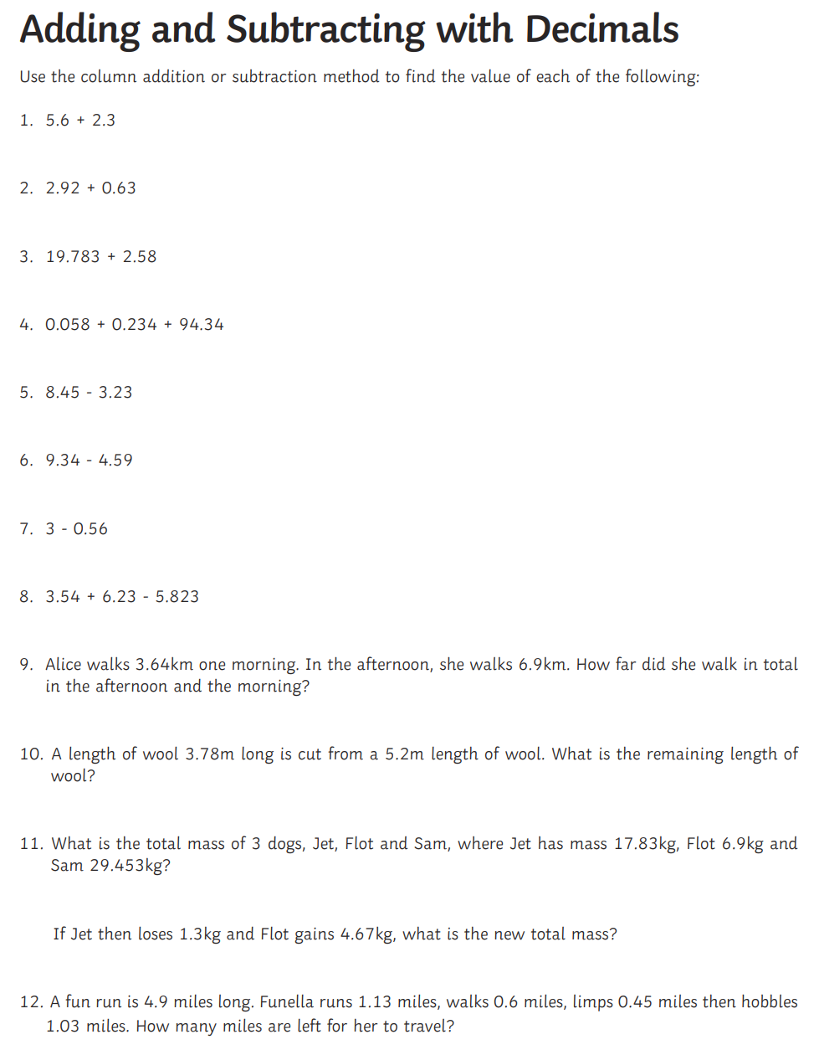

Challenge:

