Home Learning
Maths
Today, we are going to be learning about the equivalence between fractions, decimals and percentages. Please follow the link below to help you with todays learning.
Link: https://www.bbc.co.uk/bitesize/articles/zjckjp3
Please read through the ‘learn’ section and watch the video to help you. The activities will be below for you to try. Please have a pen and paper ready as you will be asked to complete some questions throughout.

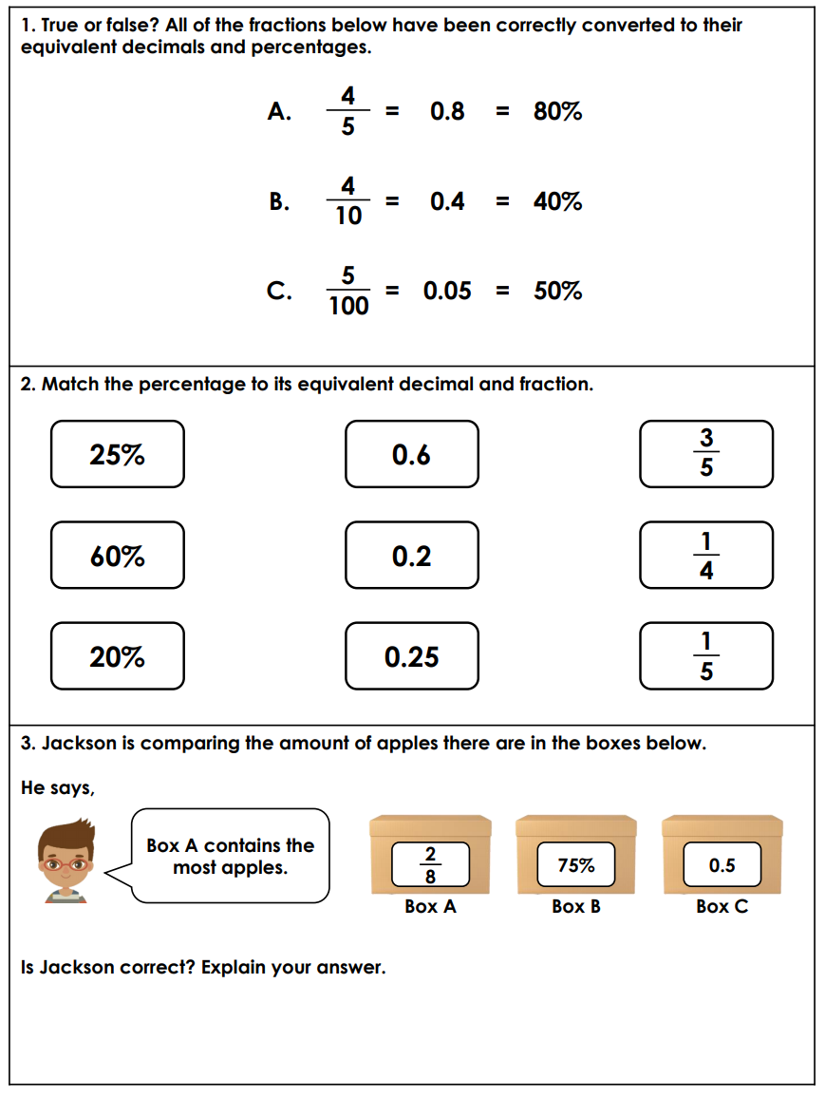
Activity:

