Home Learning
Maths
Today we are going to look at understanding Roman Numerals. Please watch the video to help you with the roman numerals. The activity will be below.
Link: https://www.bbc.co.uk/bitesize/topics/zpdwxnb/articles/zcbvhcw
Activity:
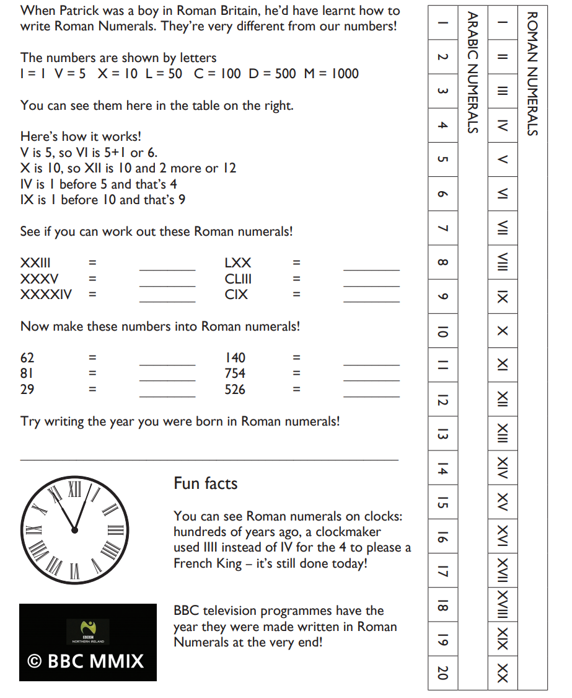

Challenges:
