Maths- Ordering Numbers
Choose Set A, B or C and to compare and order numbers. Set C is the most challenging.
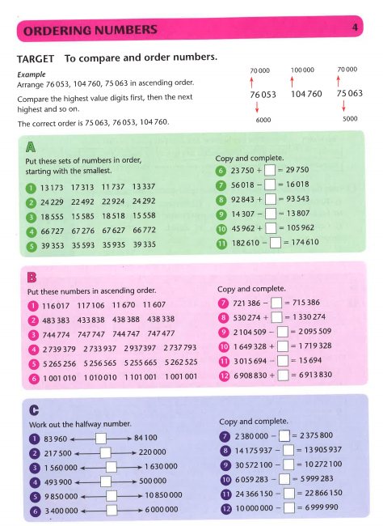
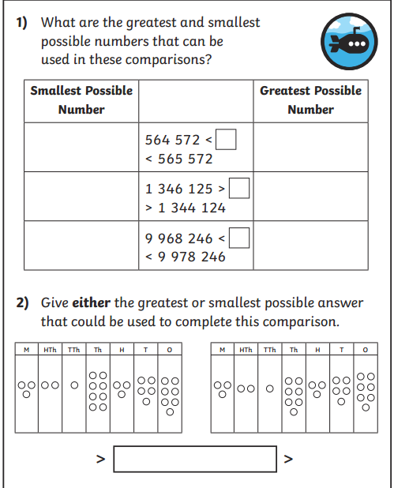
Challenge

