Maths- Place Value
Choose Set A, B or C and to identify the place value of each digit. Set C is the most challenging.
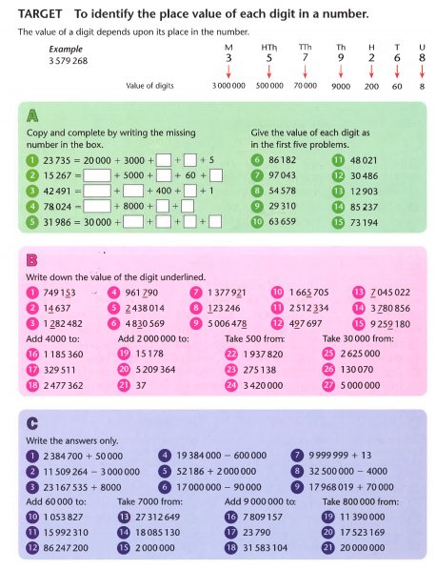
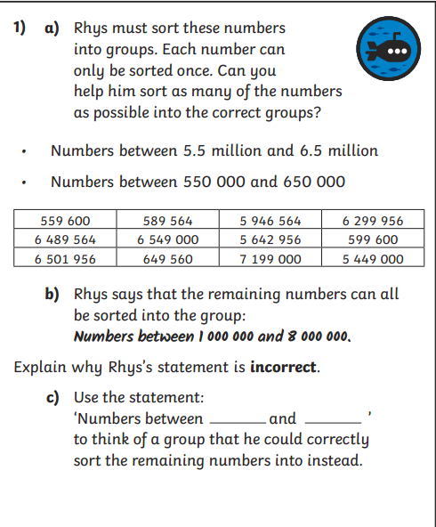
Challenge

