Maths- Rounding
Choose Set A, B or C and to round numbers. Set C is the most challenging.
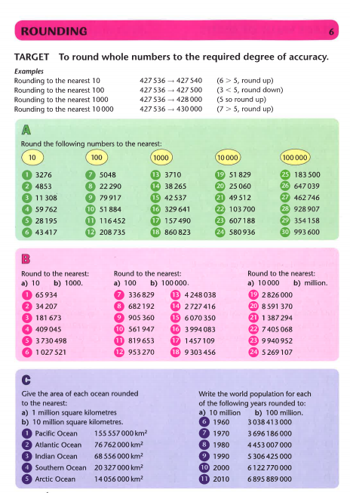
Challenge