MATHS

You must complete at least one task out of A B C. There is some extra work at the end if you wish to try it.

**A**

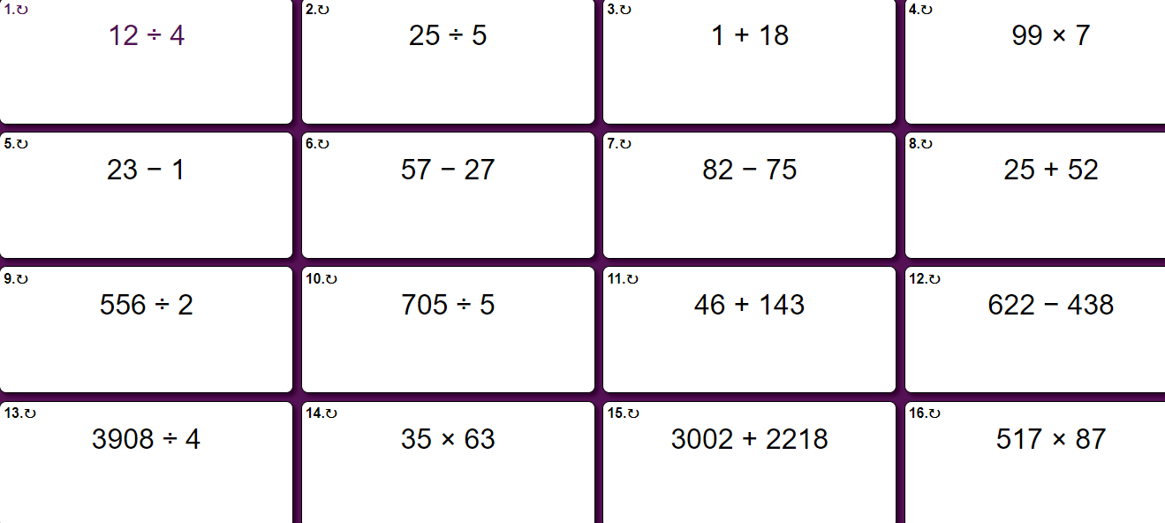

**B**

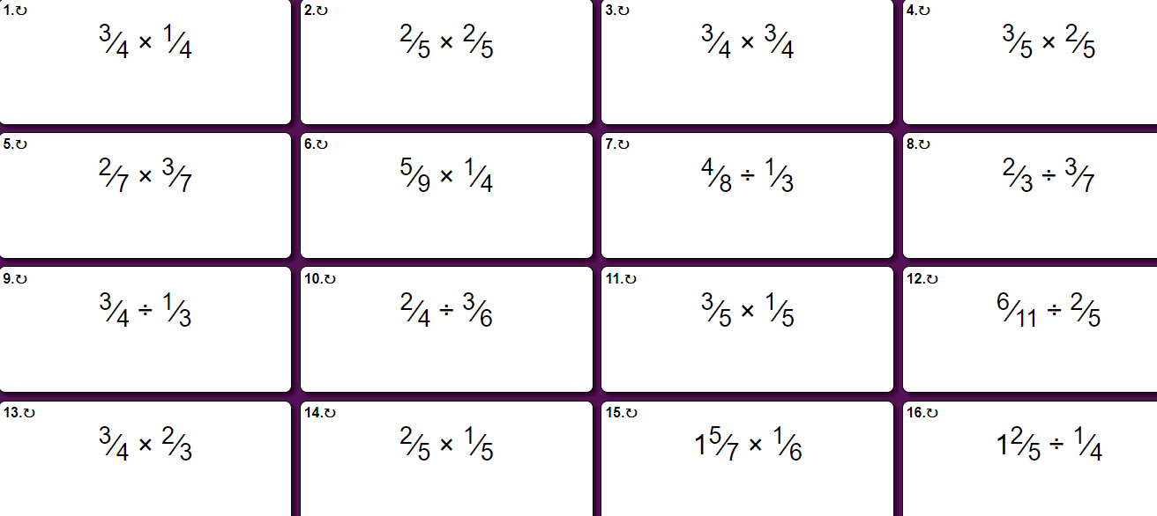

**C**

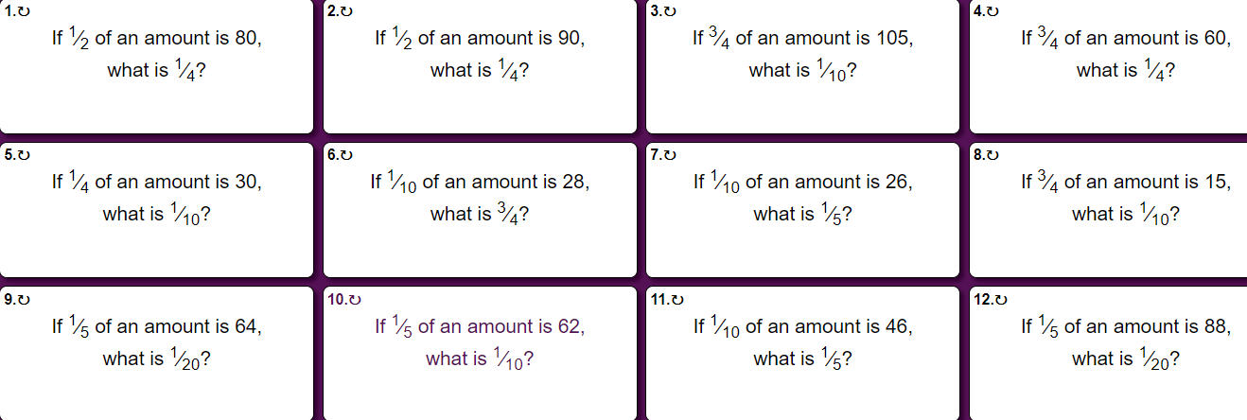

**Extra work**

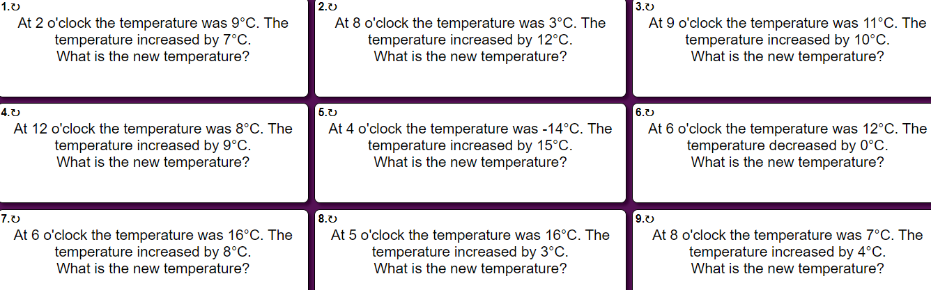

**Order of operations**

