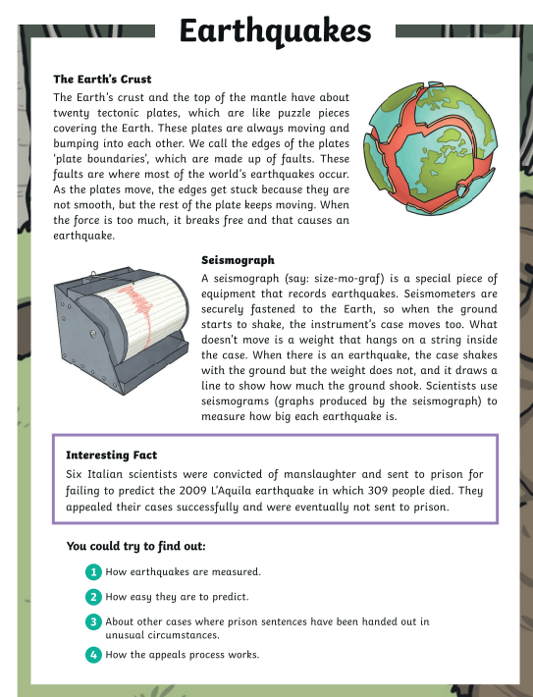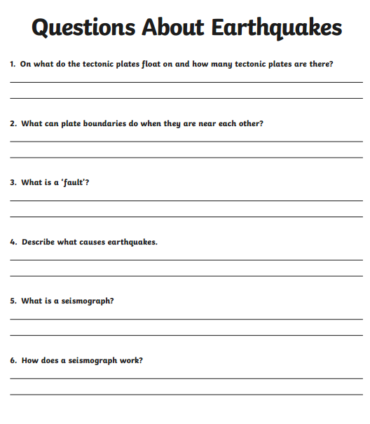
Challenge
Can you carry out your own research to find out more interesting facts about earthquakes?

