Home Learning
English
Please look at the pictures below. There is sentence that is in the wrong order. Can you help me make it right?
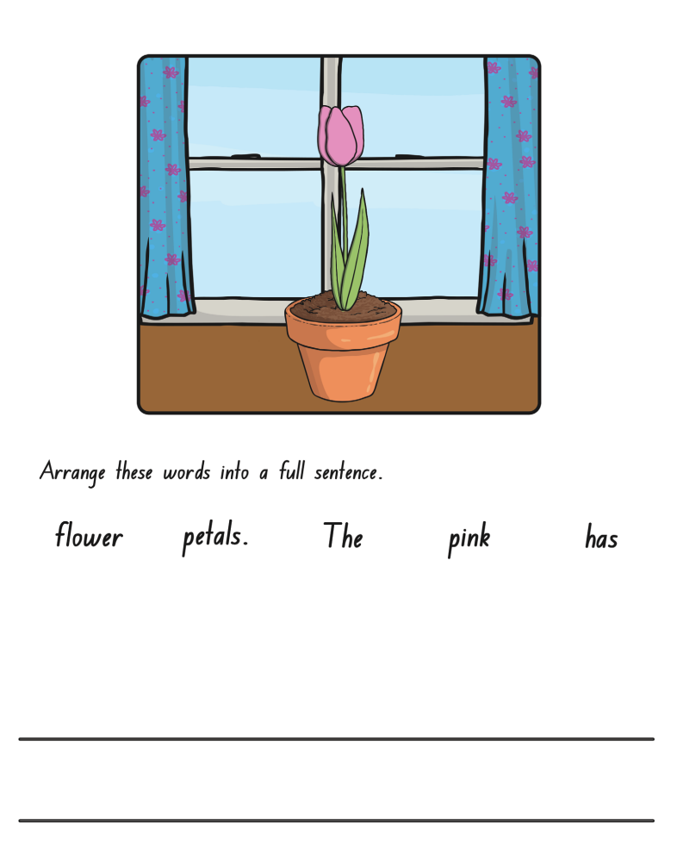
Remember: What goes at the beginning of a sentence? What goes at the end? Use those clues to work out the sentence.

