Home Learning
English
Please look at the pictures below and write a description of the cat. Please look very closely as there are lots of weird and wonderful things you can write about this cat.
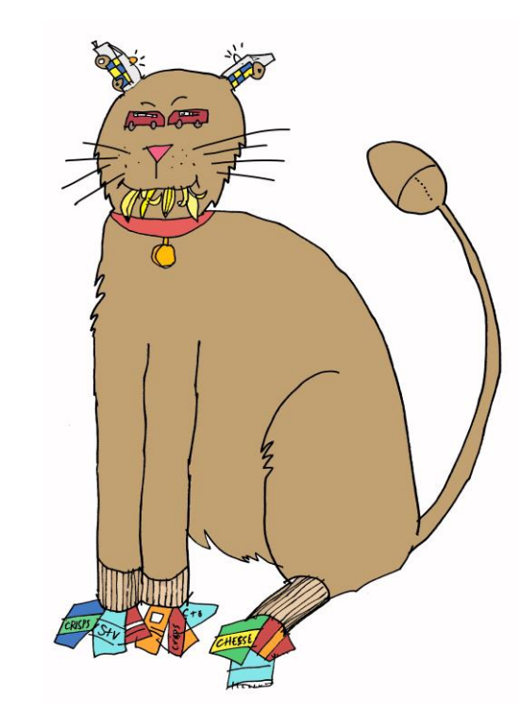

E.g The cat has fuzzy brown fur.
__________________________________________________________________________________________________________________________________________________________________________________________________________________________________________________________________________________________________________________________________________________________________________________________________________________________

