Home Learning
English
Today we are going to correct the sentences. In the sentences below, there will be a few things that could be wrong.
- Capital Letters
- Full Stops
- Spellings

1. the gurl threw the ball
____________________________________________________________________________________________________________________________________________________________________

2. max is digging in the soyl
____________________________________________________________________________________________________________________________________________________________________

3. The dug had fluffy fur
____________________________________________________________________________________________________________________________________________________________________

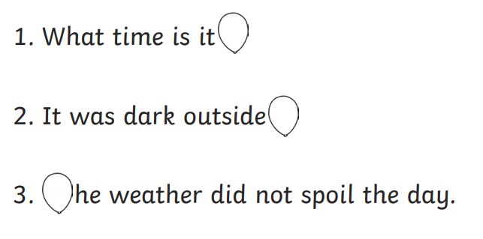
Popping Punctuation: See if you can put the correct capital letters and full stops in the spaces where the balloons are.

