Home Learning
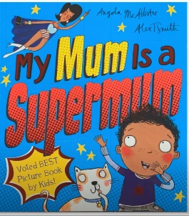
English
This week, we have been reading a new book. It is called ‘My Mum is a Supermum.’ Please follow the link below to watch a read aloud of this story.
Video: https://www.youtube.com/watch?v=awUsYB5qR5g

Read these pages from the story!
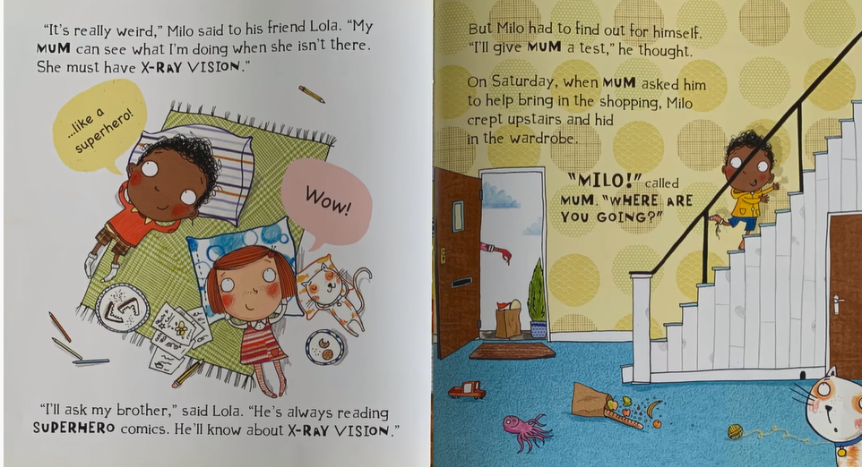
Now I know that all Squirrels have said that they think all of their adults are a superhero! Today we are going to describe what powers your adult at home could have.

Activity: We are going to fill in the blanks to change the sentence taken from the story. You can magpie some ideas from the example.

Example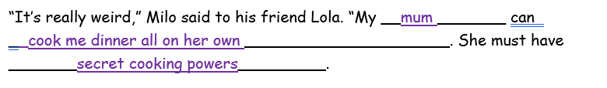
“It’s really weird,” Milo said to his friend Lola. “My ________ can ________________________________________. She must have _______
________________________________________________ .

Extension Task: Can you re-write the next sentences in the story? Don’t forget to include the punctuation.

