Home Learning
Writing
Help! The Grinch is at it again! He took the presents but he has not been found. Please write a ‘Wanted’ Poster to find the Grinch.
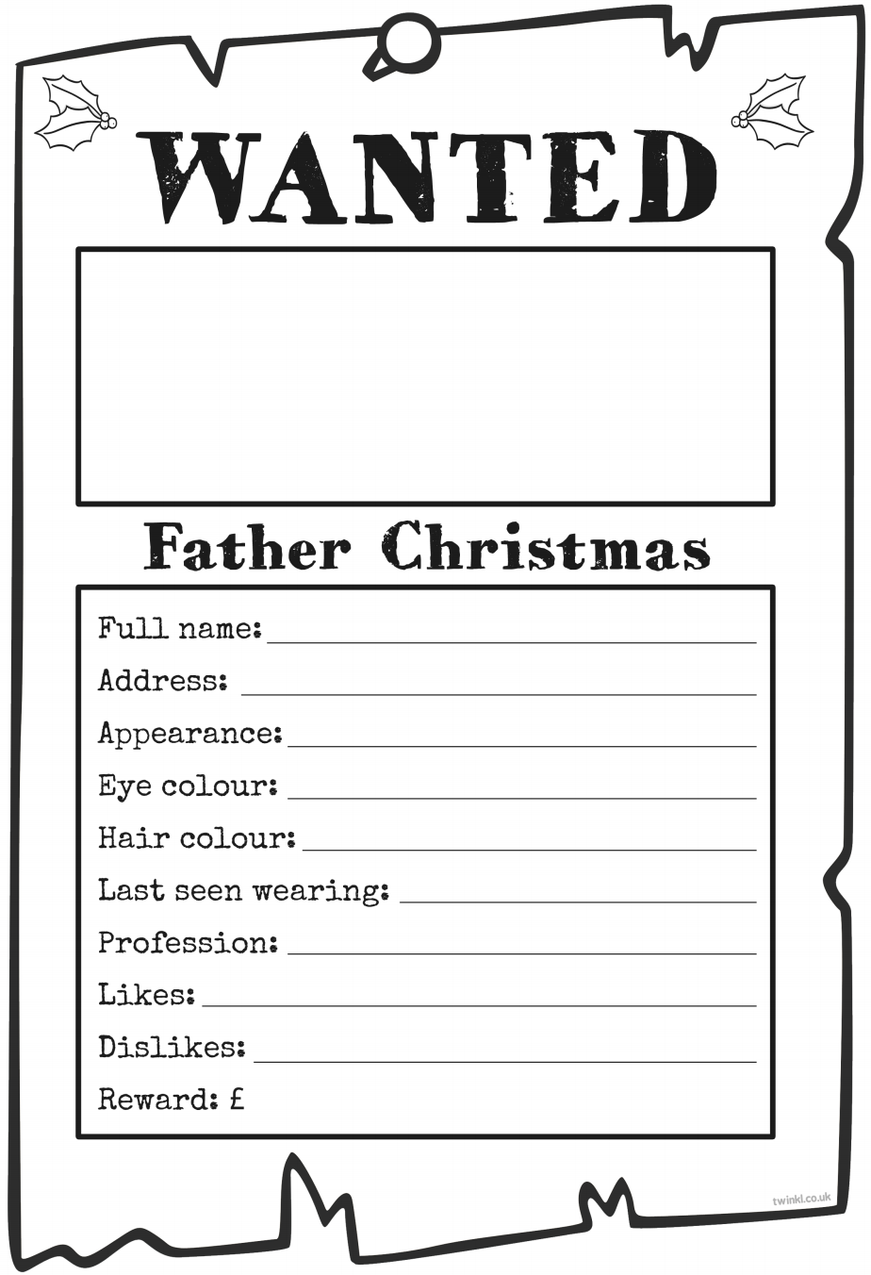
Below is a wanted poster template. Please use the template to help you create your own. You can either print this page off, or you can create your own wanted poster on plain paper.

