Home Learning
Maths
Year 1: Below there are some ten frames with counters. One frame is worth 1 ten and any in the next frame that does not fill the whole frame are ones.
Watch the video to help you: https://www.bbc.co.uk/bitesize/topics/z8sfr82/articles/zw4g2nb
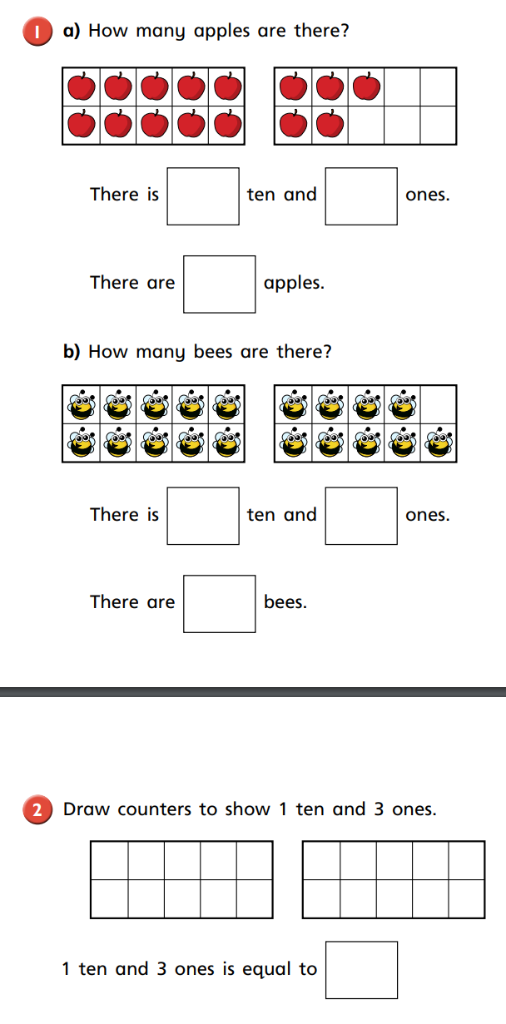

These apples fill up one ten
How many ones are there?

Year 2:
Please watch the video: https://vimeo.com/466497248
This video talks you through how to subtract a 1-digit number from a 2-digit number through partitioning.
Follow the video and work through the questions below.
Question 1: Use the number line to complete the calculations.
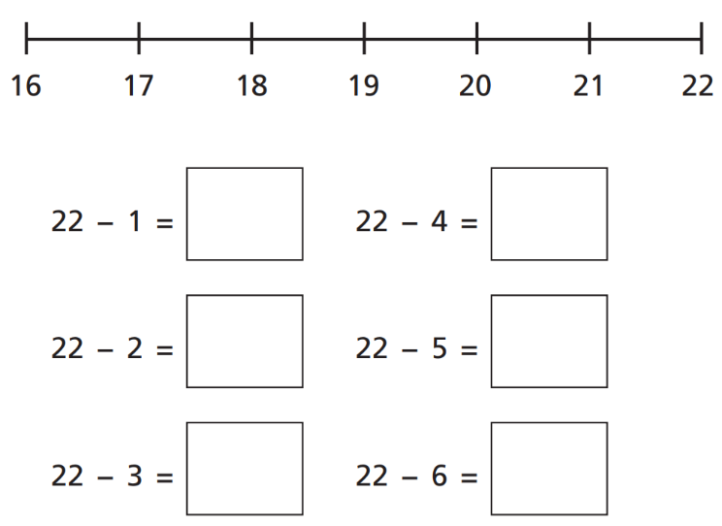

Question 2: Please work these out using partitioning.
