Home Learning
Maths
Year 1:
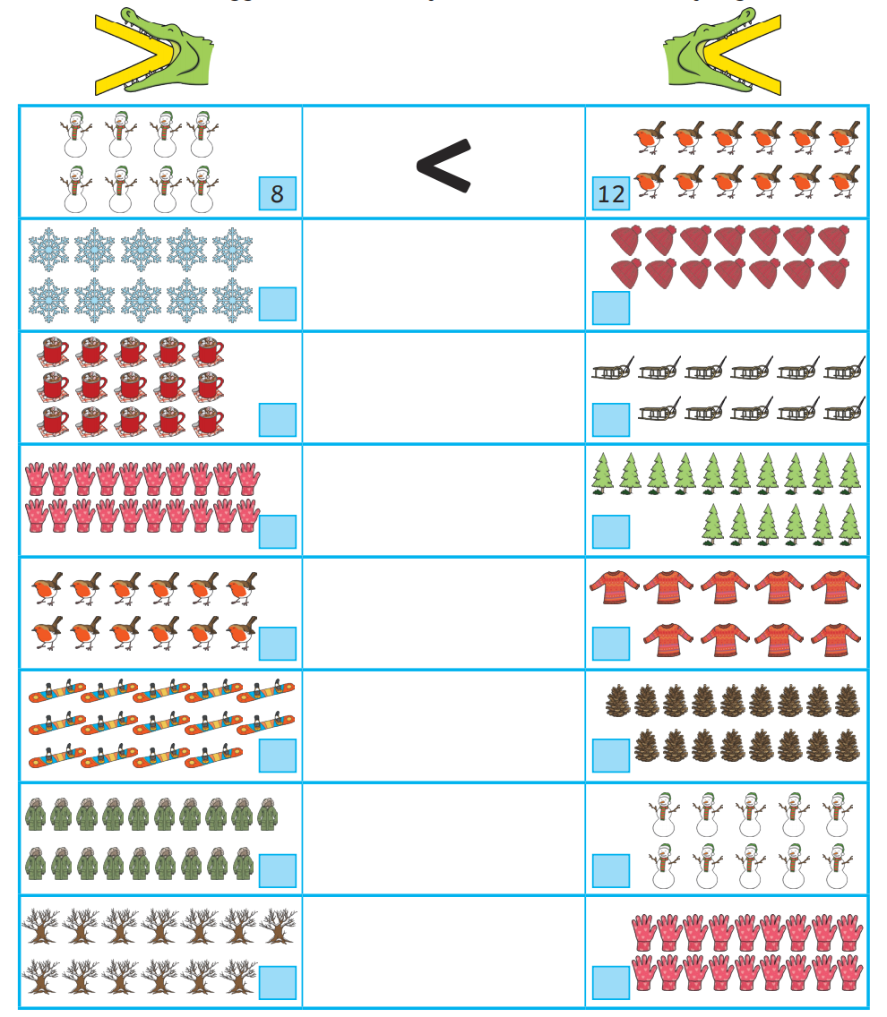
Today, we are going to look at comparing numbers within 20. Below is a sheet in which you need to count the objects and then write the numbers in the boxes next to them. Then use the gator faces <,> and = to compare them.
Year 2:
Today we are going to have a closer look at adding and subtracting using partitioning. I have worked through the first question step by step to help you.

1. First, I look at my number sentence: 12 – 9 =
3. Now, I make sure when I partition my 9 ones, 2 is one of the parts.

3
Once I have worked out everything, I need to answer the question 12 – 9 =
- Let’s start with 12 – 2 = 10
Great! We have got to our nearest ten.
- Now, we take off the rest,
- 10 – 7 = 3.
So, our answer is 3!
4. Next, I workout my other part which is… 7!
2. Next, I look at my ones in 12.
I have 2 ones.

2
8
6
9
5
25
42
15
17

14

