**Home Learning**

**Maths**

Year 1: Today Year 1s have an assessment on this past terms’ work. Please have a go at answering the questions below.

|  |  |
| --- | --- |
| **1.** | **2.** |
| **3.** | **4.** |
| **5.** | **6.** |
| **7.** | |

Year 2: Today we are going to recap making number bonds to 100. Please answer the questions below.

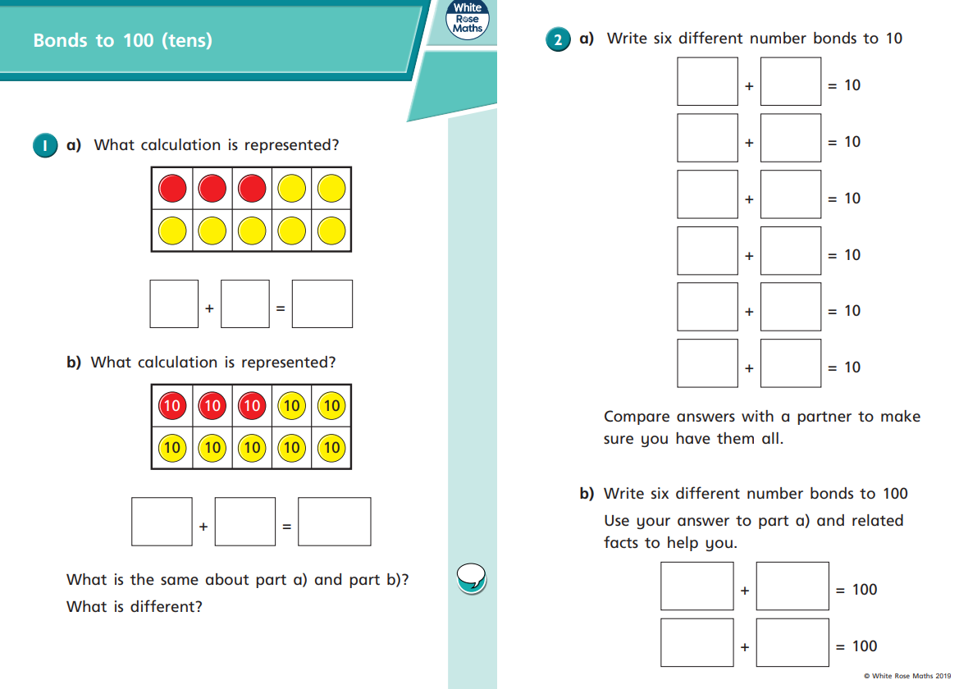

1.

2.

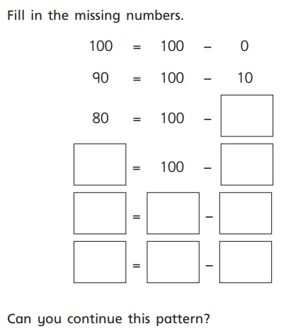3.