Home Learning
Maths
Year 1
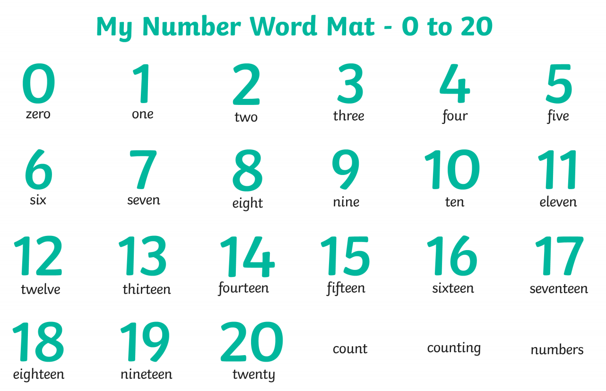
Today we are going to be learning about ordering numbers to 20 (within 20). Please look at the work below. There is a numbers word mat to help you with the orders of the numbers.

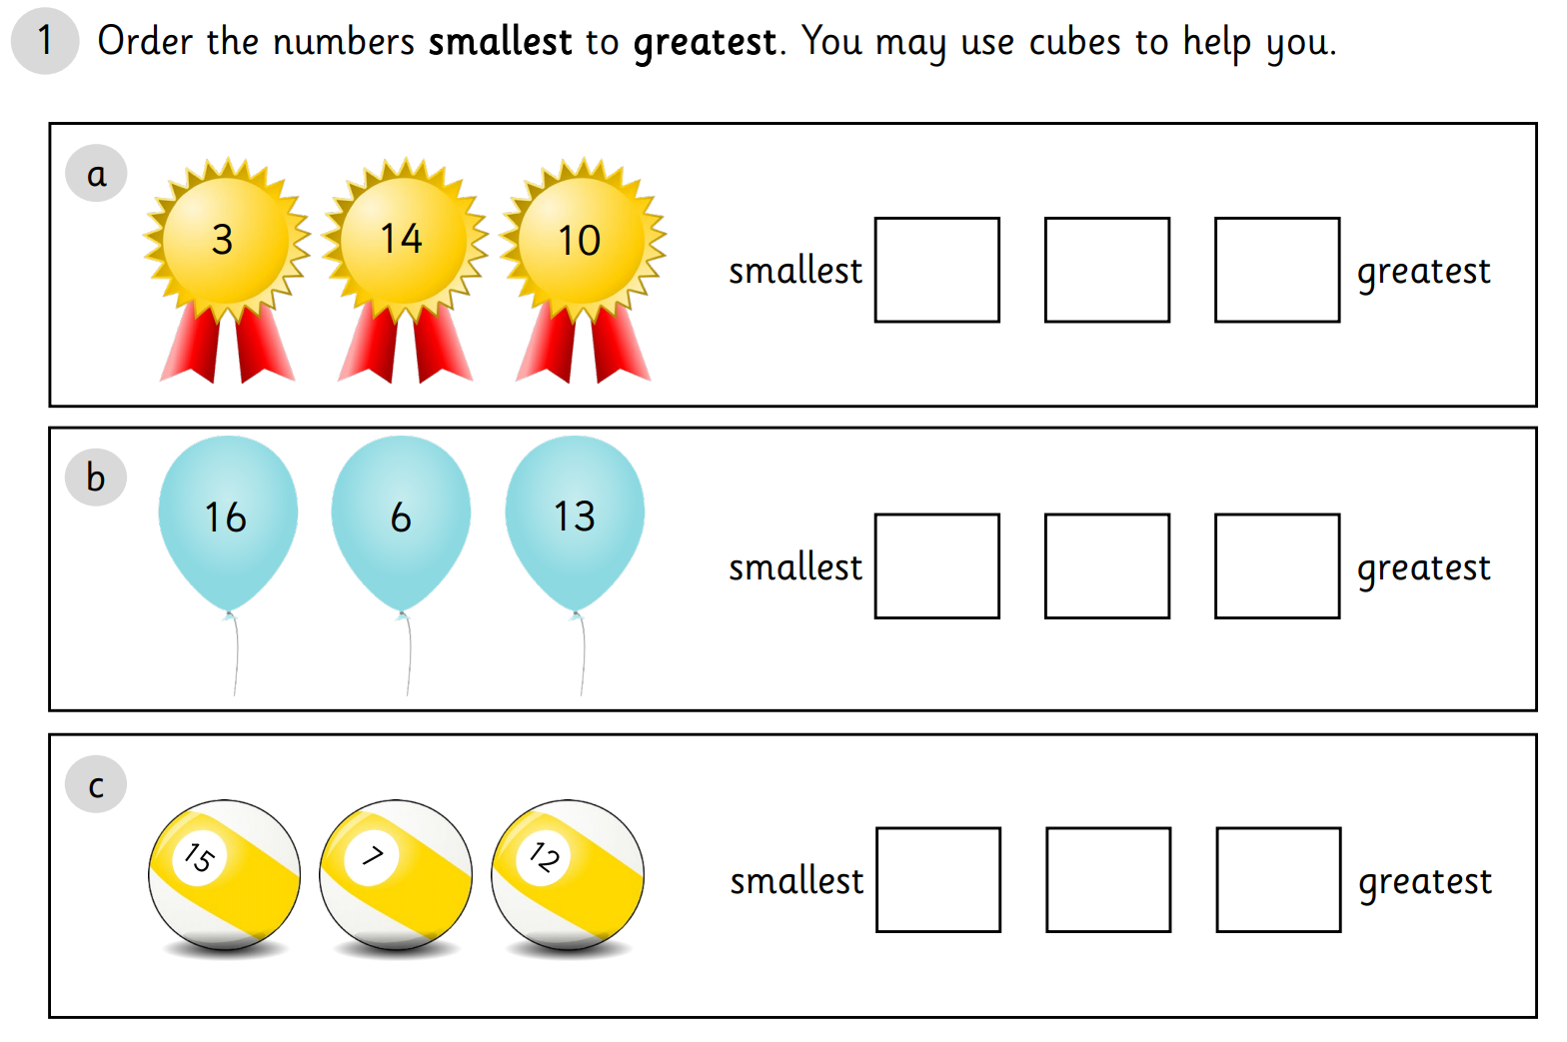
Activity:
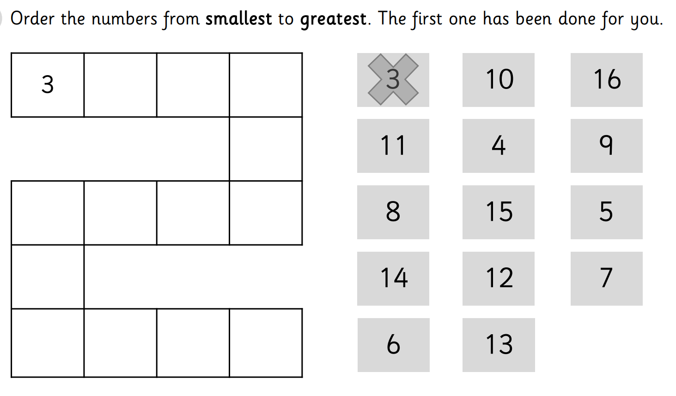
2.

Year 2:
Today we are going to be sorting 2D shapes. Please look the shapes below and see if you can sort them into the correct section. Remember to count the sides on the shapes. There is a 2D shape word mat to help you.

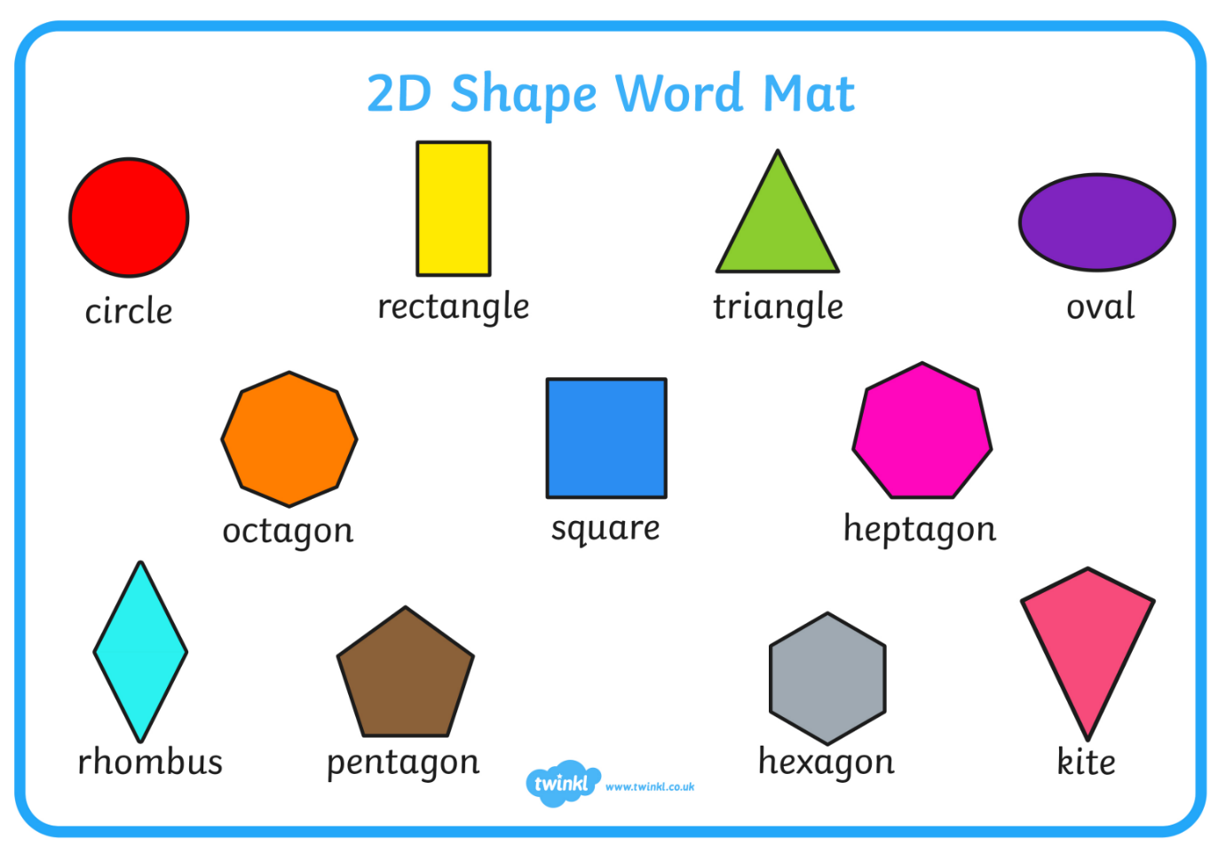

Activity: Sort these shapes into the correct part of the table.

