**Home Learning**

**Maths**

Year 1

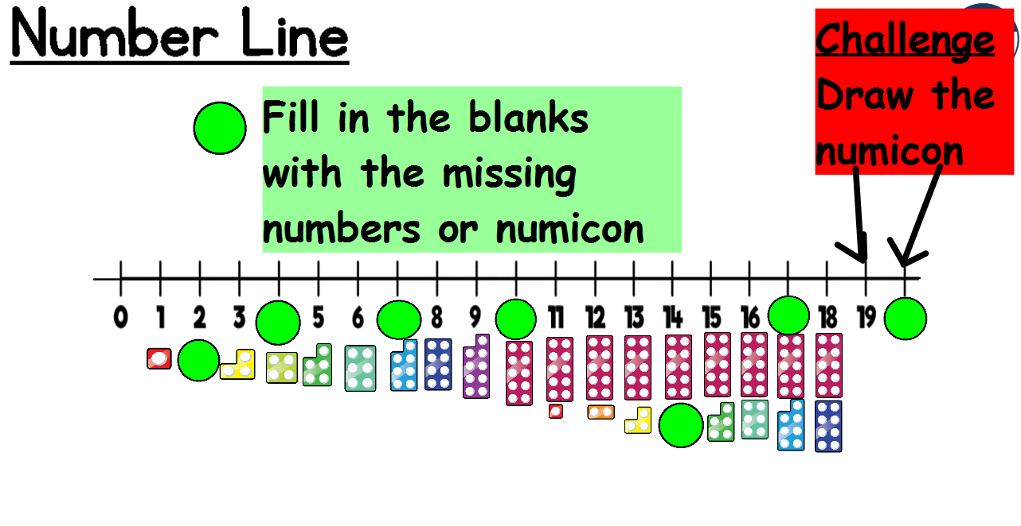Today we are going to be learning about ordering numbers to 20 (within 20).

Year 2:

Today you are learning about 2-D shapes.

Activity

Go on a shape hunt around your home.

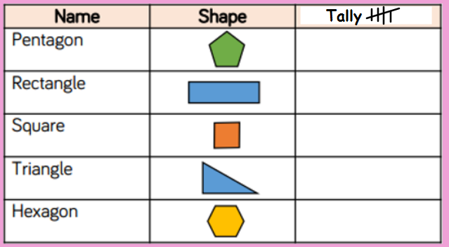Keep a tally of the shapes that you find

Challenge

