Year 1
Today we are learning about numbers within 20.
Can you complete the table by writing the missing number or representation?
Example:
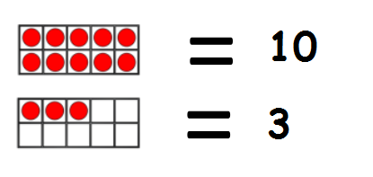
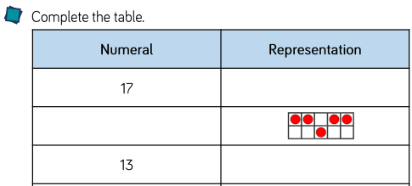

Challenge
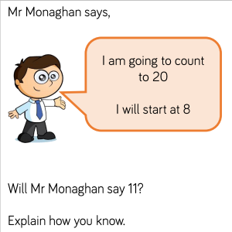

Year 2
Today we are going to count the sides on 2-D shapes.
Try and use a strategy to count the sides of a shape. For example, you may want to make a mark for each side that you have counted.

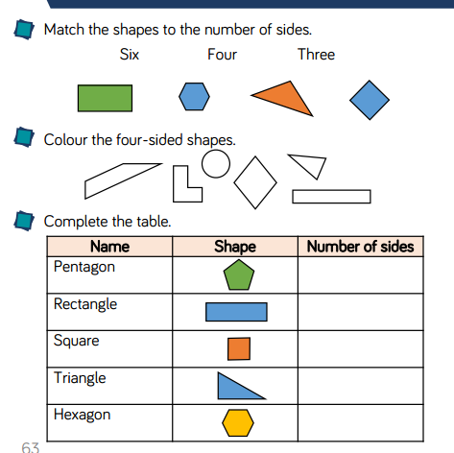

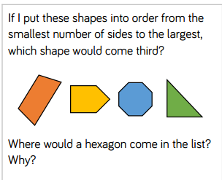
Challenge

