**Year 1**

Today we are learning about tens and ones.

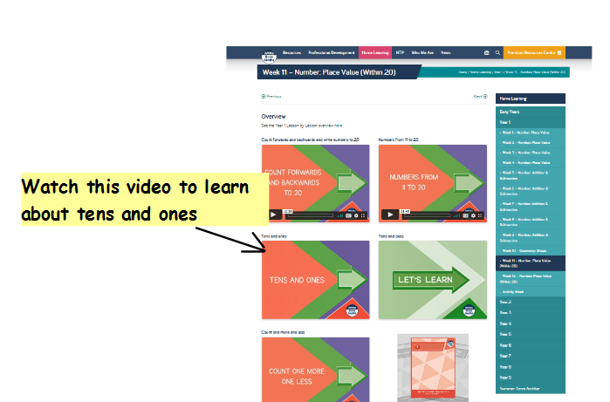If you can, watch this video about tens and ones:-<https://whiterosemaths.com/homelearning/year-1/week-11-number-place-value-within-20/>

Activity:

Can you fill in the missing information to work out how many tens and ones there are?

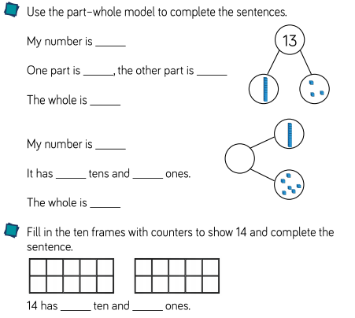

Challenge

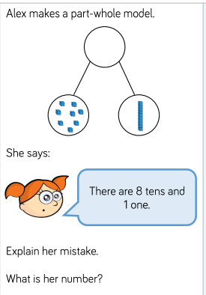

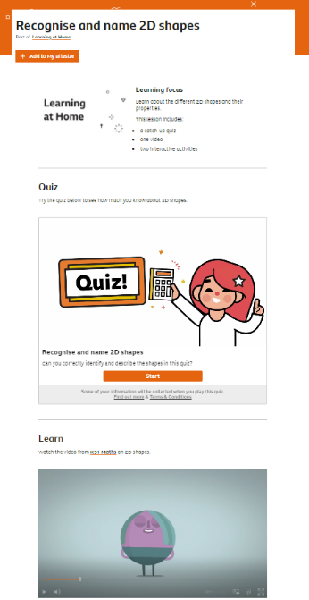**Year 2**

Today we are going to sort 2-D shapes into groups.

If you can, begin to work through the BBC Bitesize page to learn about 2-D shapes. There is a quiz, a video and some interactive activities for you to watch and practise.

<https://www.bbc.co.uk/bitesize/articles/zqdrf82>

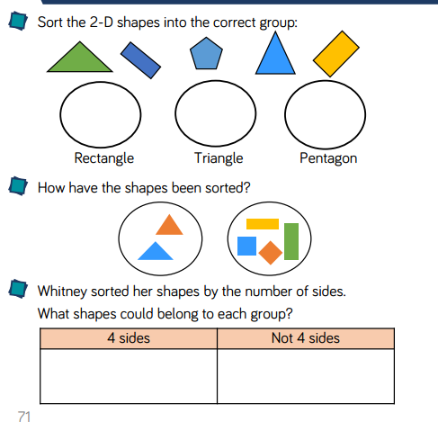Activity:

Challenge

